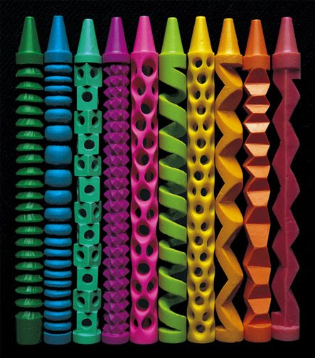
AVI 4M
Showalter
Crayon Sculptures
(images:cacholamagica.blogspot.com, toxel.com, inhabitat.com)
Continuing with our explicit use of the Creative Process in the development of our sketchbooks, you will design and create micro sculptures out of crayons.

Using your Sketchbook:
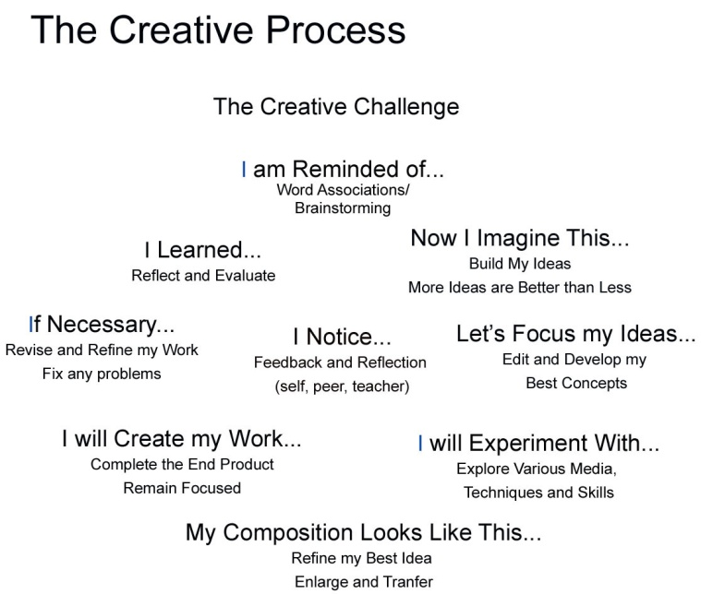
Look at the Creative Process illustrated beside. As an artist you use a combination of the steps highlighted beside to create your work. Use your sketchbook as a tool to work through your ideas in this class.

Your Challenge:
You will be given several crayons with which you will create at least one micro sculpture. Think about what the inherent qualities of wax crayons are (record this in your sketchbook). Use this brainstorming list as the starting point to transform your crayons into something new. This is a quick mini-project so your ability to adhere to a tight time line is also being assessed along with your creative response.

The Process:
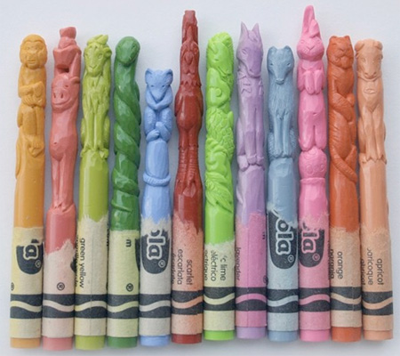
- Use the Creative Process shown and your sketchbook to develop your ideas.
- Read your challenge.
- Develop your initial responses and process as you work through your ideas in your sketchbook. Sketch, write, draw, research (books, internet, etc.) your responses into your sketchbook. Cite your sources of inspiration. (Include drawings that show the front, back and side views – 360 degrees.)
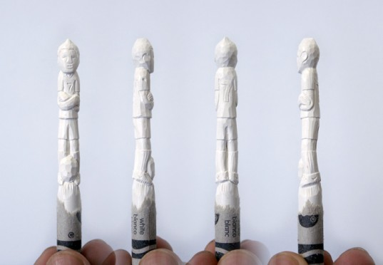
- Complete your creative response/vision.
- Class Critique.

Please Consider:
Be Creative, Take Risks, Try New Ideas
Your Crayon should be TRANSFORMED!
Think 3D and/or about the Specific Qualities that wax crayons possess

Points of Evaluation:
- Record of Creative Process in Sketchbook
- Transformation of Crayon – Strong 3D Composition
- Skill in Completion of Artwork
- Time on Task

