AVI 4M
Showalter
The Red Paper Project
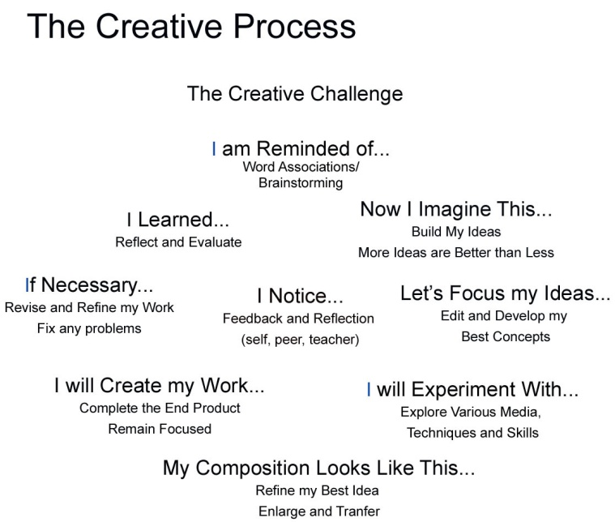
Using your Sketchbook:
Look at the Creative Process illustrated beside. As an artist you use a combination of the steps highlighted beside to create your work. Use your sketchbook as a tool to work through your ideas in this class.

Your Challenge:
You will receive a sheet of Red Bristol Board, sized 9” by 11”. You will use this paper to create a work of art. Think about the inherent qualities of paper are (record this in your sketchbook). Use this brainstorming list as the starting point to transform your paper into something new.

The Rules:
- You may not use traditional drawing and painting media (graphite, paint, ink, etc).
- You may add stuff (paper, thread, string, glue, etc) to your artwork.
- Think about the inherent qualities of paper and how you can explore this in your artwork.
- Transform your Red Paper into something new, but the initial red paper that you were given should be showcased and used as a design element.
- This is a quick mini-project so your ability to adhere to a tight time line is also being assessed along with your creative response to the Red Paper.

The Process:
- Use the Creative Process shown above and your sketchbook to develop your ideas.
- Read your challenge.
- Develop your initial responses and process as you work through your ideas in your sketchbook. Sketch, write, draw, research (books, internet, etc.) your responses into your sketchbook. Cite your sources of inspiration.
- Complete your creative response/vision.
- Class Critique.

Please Consider:  Be Creative, Take Risks, Try New Ideas  Your Red Paper should be TRANSFORMED!  Think 3D and/or about the Specific Qualities that Paper Possess’ | Points of Evaluation:  - Record of Creative Process in Sketchbook  - Transformation of Red Paper- Strong Composition  - Skill in Completion of Artwork  - Time on Task

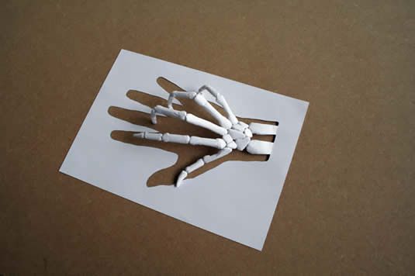 | 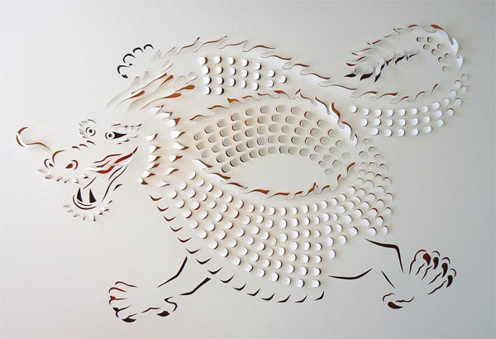 | 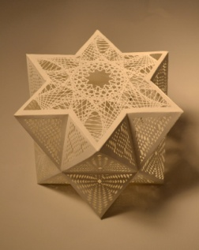 | 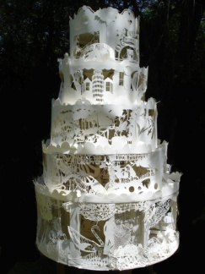 | 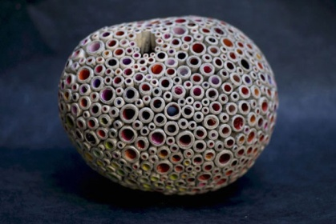
Peter Callesen  webdesignerdepot.com | Paper art by Lisa Rodden.  inspirefusion.com | by Tahiti Pehrson  strictlypaper.com | paper_sculpture.jpg  juliusbrillante.wordpress.com | Paper Sculptures ...  thisiscolossal.com

