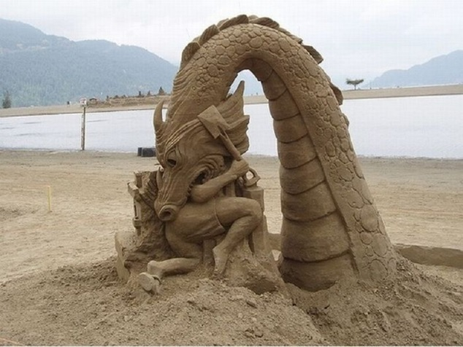
Theory Friday Links
- SAND ART
http://iwastesomuchtime.com/on/?i=88232
Sand art is the practice of modeling sand into an artistic form, such as sculpting, painting or bottles. Such creations require water and sand, and quite a lot of patience. Amazing structures are created from what seems meaningless!

- BE GREEN: LAWN MOWER
http://iwastesomuchtime.com/on/?i=88020
South Korea came up with an innovative design for a lawn mower that was environmental friendly and gave a new concept to having fun outdoors! Muwi, the creation, calculates the size of the lawn and automatically cuts the grass and accumulates the grass inside into a compressed cylinder or a ball and can be made into anything! The kids can play with the balls, or a chair could be created from the cylinders, the possibilities are infinite!

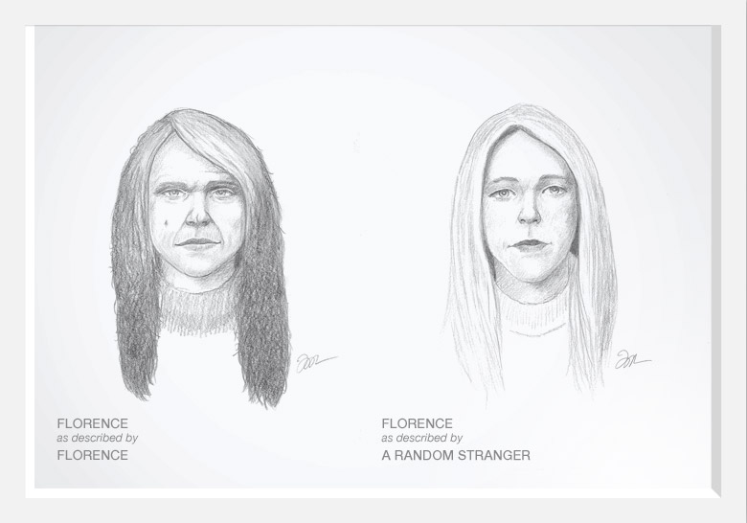
- DOVE COMMERCIAL: SELF VS OTHERS
http://www.youtube.com/watch?v=litXW91UauE
This commercial is created by Dove to show the extent that a woman`s self-esteem can drop to. Their opinion and view for themselves contrasts heavily with those of others. Society and media portray women sexually and set the stage for what is `perfect`. This commercial portrays how some women see themselves compared to how the world sees them.

- TEACHERS
http://www.youtube.com/watch?v=l48FyAmQNOc
This video is a portrayal of how much impact one can have on someone`s life. This commercial is about the importance of teachers and how big of an impact they can have on their students. It is touching, and heartwarming, but it also raises respect for teachers and their place in our lives.
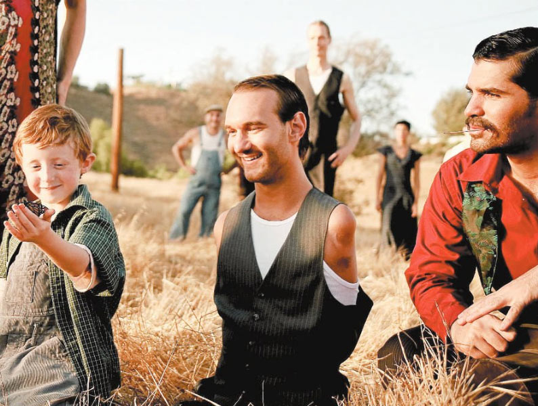
- THE BUTTERFLY CIRCUS – SHORT FILM
http://www.youtube.com/watch?v=p98KAEif3bI
The butterfly circus is a beautiful short film about a man with no limbs being presented to the world in a freak show. He is treated with disrespect and disgust until a circus ring leader speaks to him with kindness about joining his team. This movie portrays the beauty in our world and how materialistic things and the easy way of living cause us to forget that we should be grateful for the little things in life.

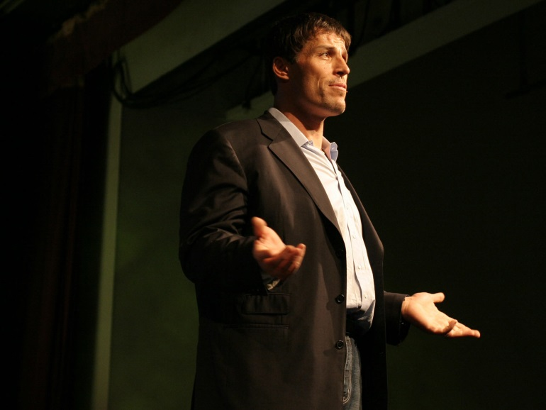
- WHY WE DO WHAT WE DO
http://youtu.be/Cpc-t-Uwv1I
In this video, Tony Robins speaks about the emotional involvement and mentality of why and how we make decisions that impact our lives. He speaks in great detail of what causes of to be determined and what makes great heroes. This video is inspirational and eye-opening to how we make the ultimate decisions that may or may not change our lives.

- TO THIS DAY
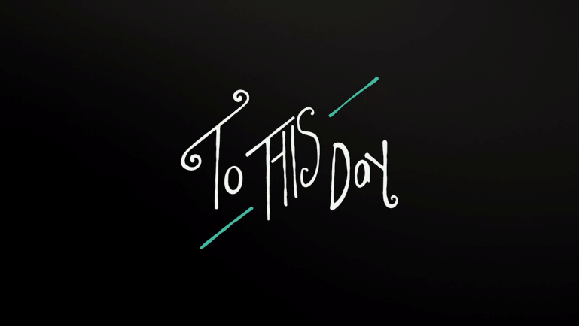
http://www.youtube.com/watch?v=ltun92DfnPY
To this day is by Shane Koyczan. His powerful words almost bring its viewers to tears by the immensity of emotion he verbally communicates, as well as the amazing animation that creates an enhanced mood. This story tells the tale of many people around the world, motivating them to stand up for themselves.
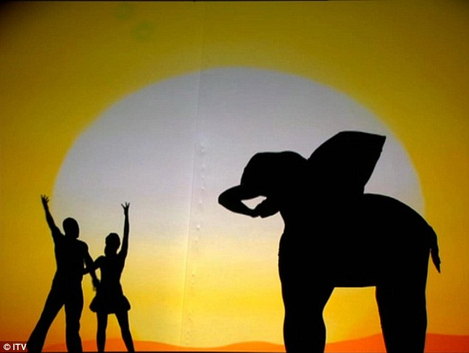
- SHADOW DANCE
http://www.youtube.com/watch?v=CvQBUccxBr4
Shadow dancing has taken a completely new twist as people use their bodies, positioning themselves according to shadow and distance to create figures, buildings and animals! This video expresses the imagination of people and what we can create.

- WATER ART
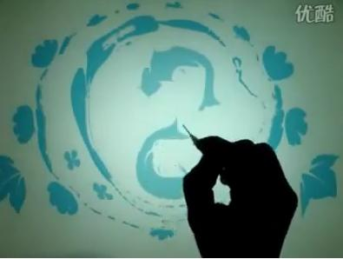
http://www.youtube.com/watch?v=RkSceFMJPxI
Water art is quite exquisite as it presents something that seemed quite impossible! The painting on water forms from drops of colour, and where they seemed that they would dissolve, they spread into figures and actual shapes!

- HAND ART
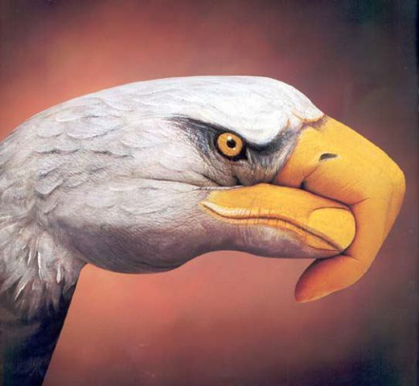
http://www.noupe.com/inspiration/awesome-hand-painting-art-by-guido-daniele.html
Hand art is absolutely gorgeous! The artists paint their hands to create illusion of being an animal or an object. Until you look closely, you cannot tell it is a hand! The art is done so beautifully and accurately, it hides the hand and creates a beautiful image.

