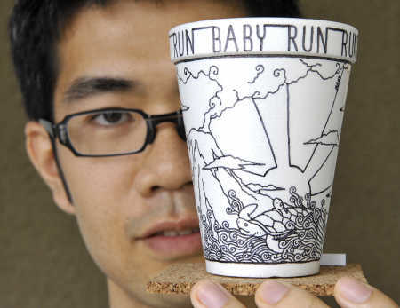
AV1/AWM 3M
Showalter
The Cup Project

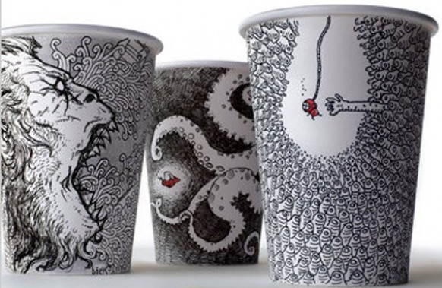
Cheeming Boey is a California-based artist who has gained notoriety for the AMAZING art he creates on coffee cups. By combining two very simple things, paper cups and Sharpie Pens, he creates museum-worthy masterpieces that continue to ignite interest around the globe. In the same way that Warhol made soup cans famous, Boey is pushing the limits of pop culture with his coffee cups.

From an interview on BoingBoing: Â You draw on styrofoam cups. But we throw those away! That's crazy! Why do something so crazy?
I didnâ€™t think it was crazy. People draw on napkins, receipts, wood. I was outside a coffee shop and had the urge to sketch while Â people watched. I found a foam cup on top of a trash can, and it was all I had, so that was what I worked with. It turned out nice, and I kept it. Then I made it a point to collect more, so I drew on more cups. One day a co worker asked what I was going to do with all the cups I had around my workspace, and I said,â€ theyâ€™re nice, maybe I can sell them one day.â€ To which he said, â€œno one is going to buy that crap.â€ And here I am... http://boingboing.net/2011/01/19/cheeming-boeys-styro.html

Your Challenge:
- Either working individually or with a partner, each person will design and complete their own cup. If working in a partnership, both cups will work together when completed.
- You will trace the cup pattern on a scrap sheet of paper (white) and attach it to the surface of your cup.
- Using a black pen or marker, complete your design using whatever mark making you feel will emphasize your work.
- You may use one other colour in your design besides the black of your pen/marker.
- You will present your finished design, individually or in your partnership to the class in a small critique.

Evaluation Critera:
 | Communication |  | Knowledge/Understanding | Thinking/Inquiry | Application
 | - Critique Presentation  - Visual Literacy |  | - Mark-making that enhances subject matter | - Creating a design that works on the cup (inside, outside & underneath) | - Finished Result  - Attention to detail
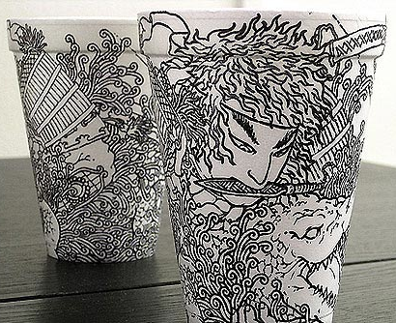 |  | 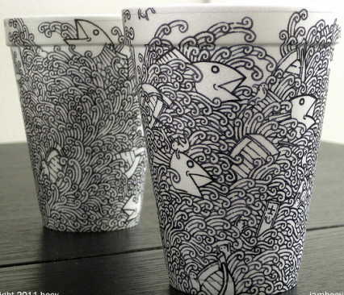 |  | 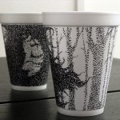 | 