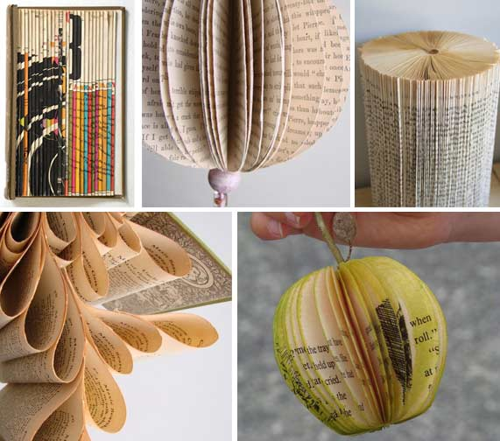
AVI 3M
Showalter
The Altered Book Sculpture
Your Challenge:
You will choose a second-hand book that will then be used to create a three-dimensional sculpture. How you interact with your book is up to you… fold, cut, tear, glue, re-assemble, etcetera. But most importantly, play and have fun with this; take some creative risks!

The Process:
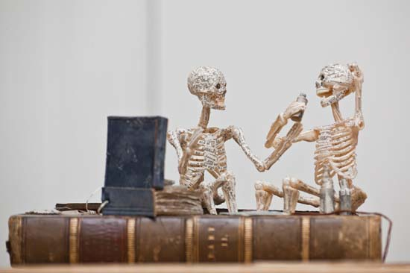
- Choose a book from the selection of books that your teacher will provide for the class.
- Brainstorm in your sketchbook the things that you can do to paper &/or books. Write, sketch, etc these responses.
- Research how other artists have used books to create sculptures. Use your device and google, site sources, print off images, examine artists, etc to be included in your sketchbook.
- Experiment with what you could do with your book.
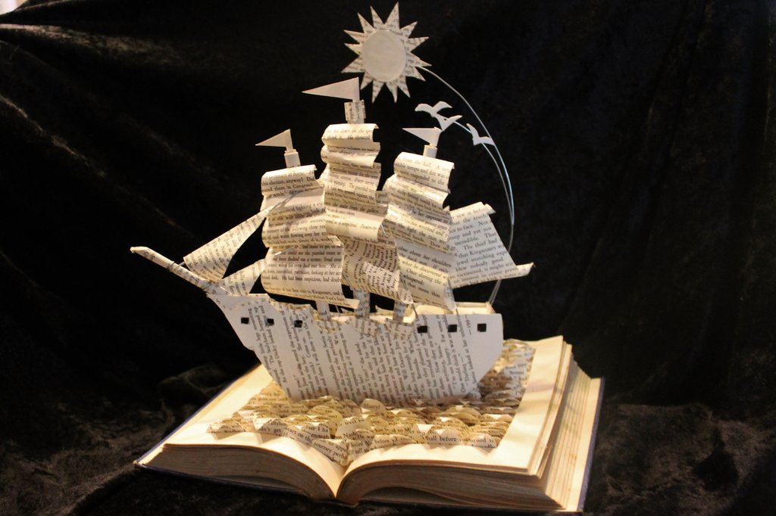
- Play with the properties of paper and think about how you can approach it in different ways. Record your ideas.
- Think about which ideas will work.
- Do you need to learn any new skills?
- How long will it take to create your vision?
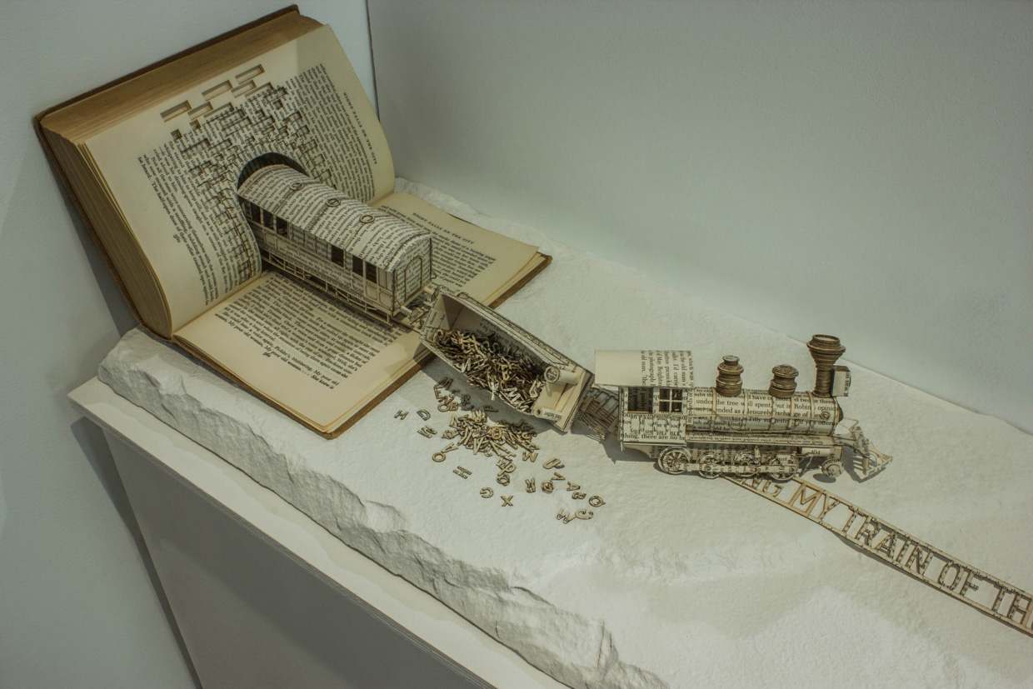
- Create at least three thumbnail drawings that show your interactions from the step above. Attach any research that you do in your sketchbook if it is required to develop your drawings.
- Record your ideas (drawing & text).
- Think about which ideas will work.
- Do you need to learn any new skills?
- How long will it take to create your vision?
- Choose the thumbnail drawing that best pushes the idea of a book sculpture and create it…
- Present your finished sculpture to the class.
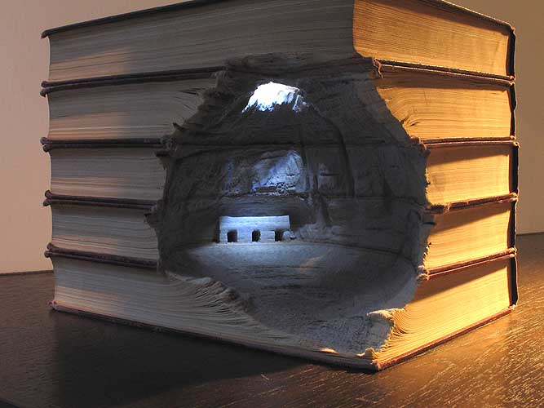
- Complete the response journal.

Points of Evaluation:
- Concept (sophisticated idea that relates to book + thumbnails)
- 3D Form (composition & interest of sculpture from all sides)
- Paper Medium (understanding of additive/subtractive techniques)
- Time On Task (effectively uses time to complete work)
- Attention to Detail (overall, finished item shows creativity, skill and detail
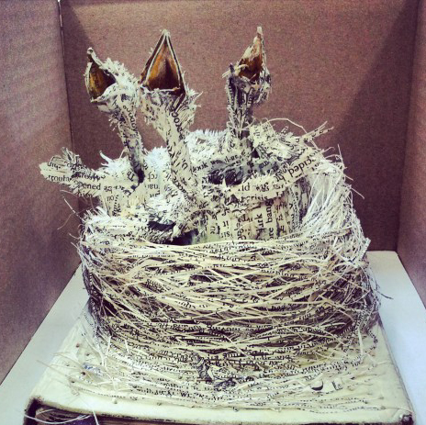
Note: Use scissors and white glue to maintain the integrity of the book.

Images:
‪evie-s.com
http://smashinghub.com/creative-paper-book-sculptures-pop-up.htm
wetcanvas.deviantart.com
http://www.bitrebels.com/lifestyle/book-sculpture-illustrates-ocdtrain
‪9wows.com
‪www.abebooks.com

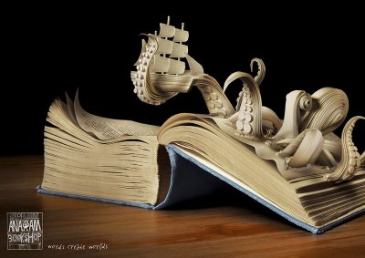
Showalter Name:
EVALUATION: The Altered Book
(Image: ‪www.offbeatearth.com)
Points of Evaluation: Please explain how you incorporated the following aspects as you created your sculpture. Then determine the level you feel you earned for each component.

- Concept (sophisticated idea that relates to book + thumbnail sketches)
Student Level _____/Teacher Level _____

- 3D Form (composition & interest of sculpture from all sides)
Student Level _____/Teacher Level _____

- Paper Medium (understanding of additive/subtractive techniques)
Student Level _____/Teacher Level _____

- Time On Task (effectively uses time to complete work)
Student Level _____/Teacher Level _____

- Attention to Detail (overall, finished item shows creativity, skill and detail
Student Level _____/Teacher Level _____

