AVI 3M Trivedi/Showalter
Art as Therapy and Meditation
We live in an age where there are pressures to live in a fast paced lifestyle. It seems we have so much to do and so little time. This can cause anxiety and stress on an individual. It is important to find ways to release our stress and slow ourselves down, being mindful of our health and well-being. Productive ways to bring inner peace are by meditation and using art forms as an outlet.
- Music and Drawing (1 Sketchbook Page to be submitted)
- Meditation Group Activity
- Yoga lesson with Ms. Wightman
- Meditation Powerpoint
- Landscape Powerpoint: Please take notes.
- Elements of Design
- Landscape Collage (2)
http://taoeaac.blogspot.ca/2013_04_01_archive.html | 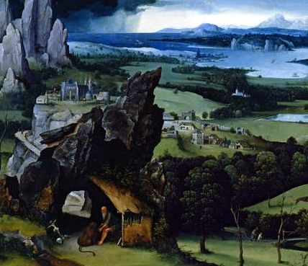 | 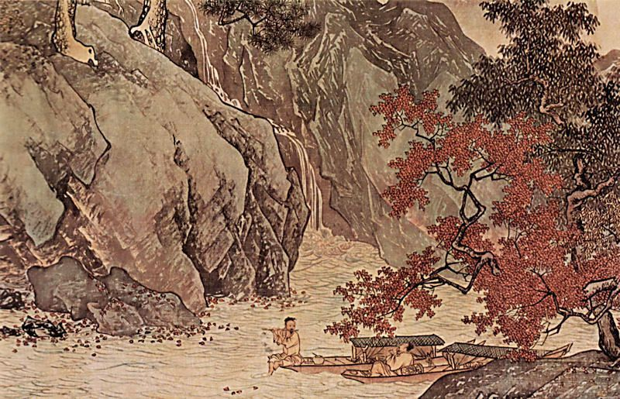 | http://www.artble.com/imgs/3/f/4/534414/  wanderer_above_the_sea_of_fog.jpg
http://www.artble.com/imgs/3/f/4/534414/wanderer_above_the_sea_of_fog.jpg | 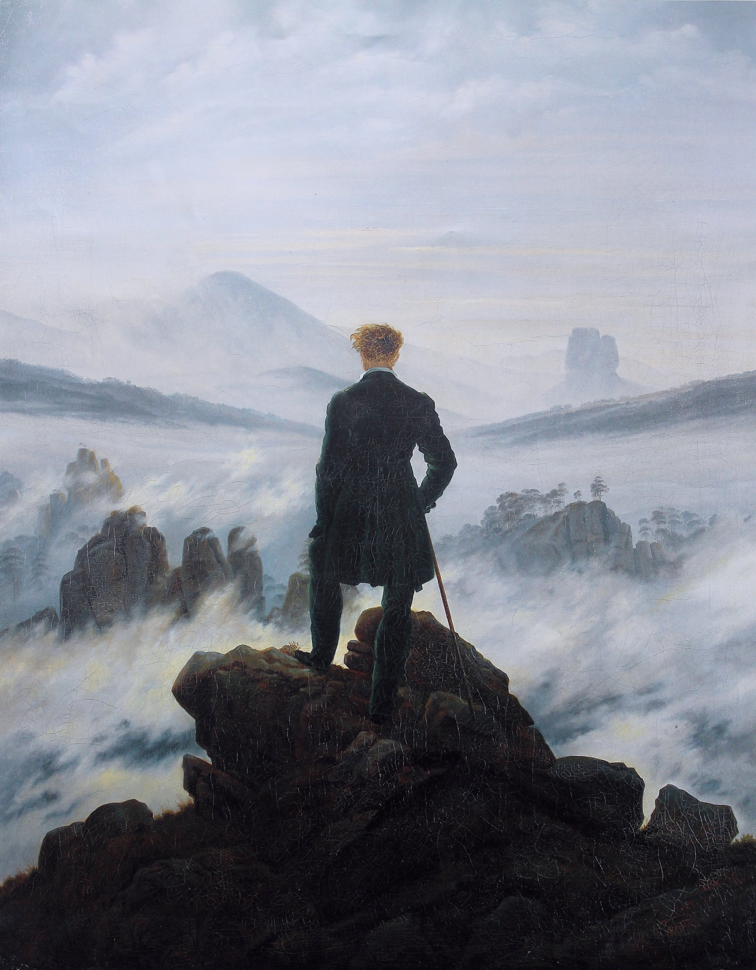 | 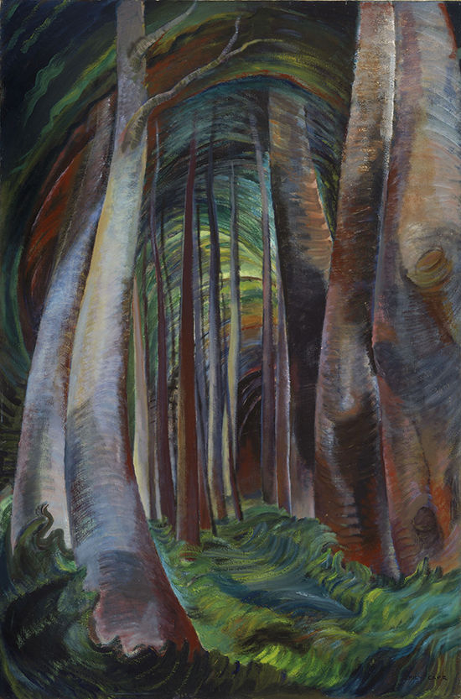 | http://www.akimbo.ca/43783
www.vangoghmuseum.nl/vgm/mmbase/images/223353 | 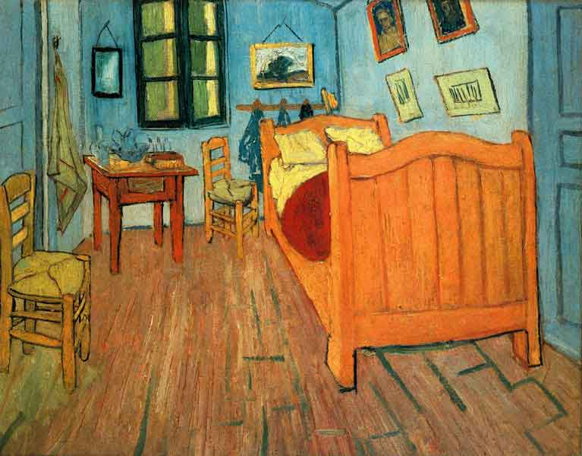 | 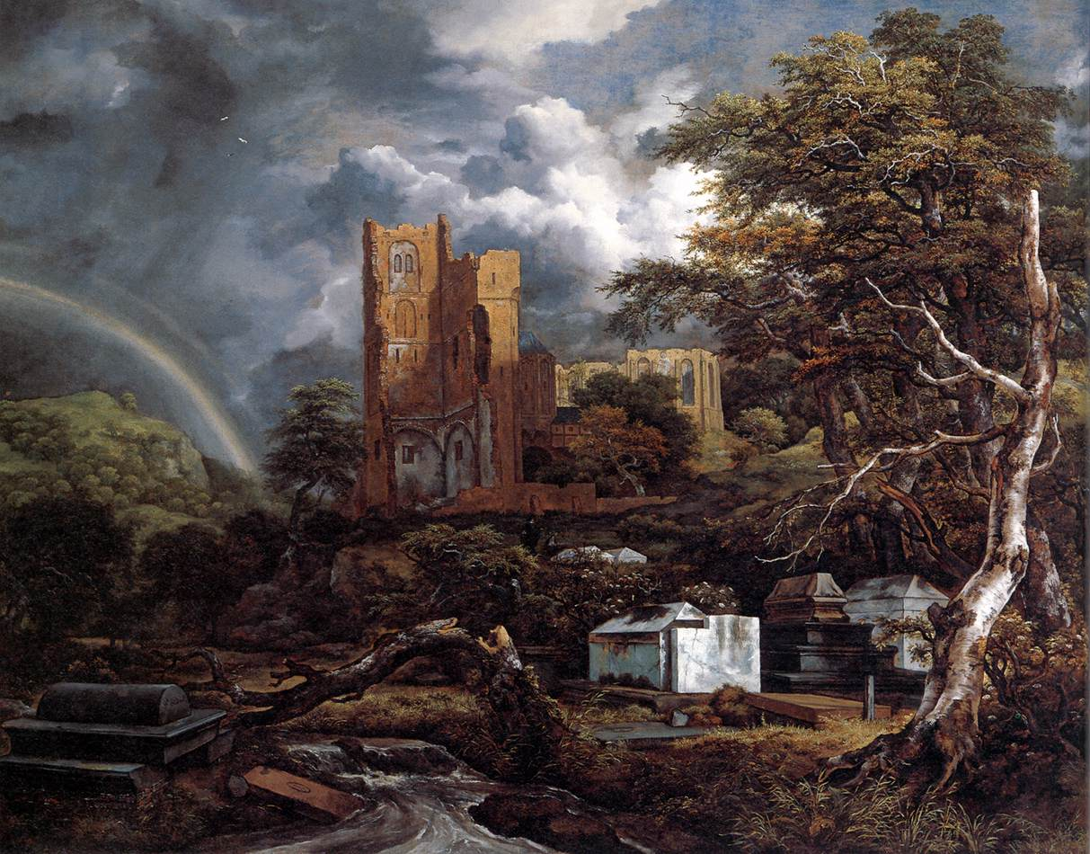 | commons.m.wikimedia.org/wiki/File:Jacob_Isaacksz._  van_Ruisdael_-_The_Jewish_Cemetery_-_WGA20486.jpg
What is meditation?
Many cultures use meditation as a way to balance the mind, stay positive, and in doing so, develop compassion. In the past, religions like Hinduism and Buddhism used various forms of meditation as part of their religious practice. Today, many cultures and religions also use meditative components like closing their eyes, saying prayers, using rosary beads, reciting quotes and practicing breathing to take away stress. Others use forms of meditation in a variety of non-religious ways to keep one's body flexible, strong and healthy. Some use yoga, and artistic forms such as dancing or even painting to create their art. What comes to mind when you think of inner peace?

AVI 3M
Landscape Dissection

PART ONE: The components and Characteristics of a Landscape:
Background:  -Furthest away from the viewer  -Highest on the picture plane  -Lightest value  -Least detail  -Smallest objects  Middle-ground:  -Furthest away from viewer  -Behind the foreground objects  -Part way up on the picture plane  -Some detail  -Medium value  Foreground:  -Closest to the viewer  -Bottom of the page  -Dark values (high contrast between lights and darks)  -More/most detail  -Biggest objects  -High contrast of tones | Find three photographs in magazines/online. You must bring them in hard copy form to class.  In your Sketchbook:  One image will show a strong example of foreground.  One image will show a strong example of middle ground.  One image will show a strong example of background.  For each of the above images, you will highlight (draw around the part that you have identified) the type of ‘ground’ being shown. You will label and write down the definitions beside with the image.

Part TWO: Write or draw the elements that relate to inner peace:

Colour Line Shape

Value Texture

Sketchbook Assignment: Think about where you feel peace. Bring in images from magazines or the internet that represent what peace is to you. Keep in mind of the elements above (colour, line, shape, value, texture). Magazines will also be provided in class. You will use these to recreate a landscape with a background, middle-ground and a foreground in your sketchbooks. You will complete two in your sketchbooks.

