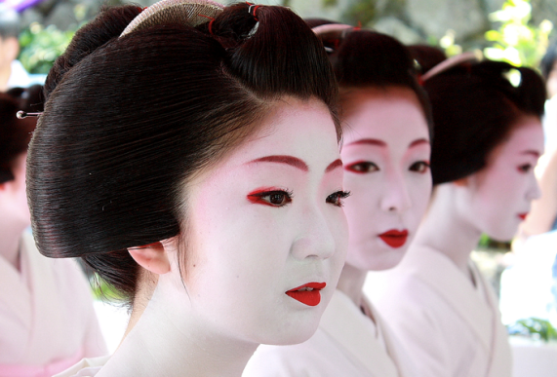
Visual Arts
Showalter
Body Ornamentation Designs
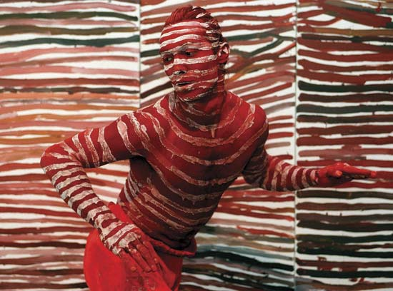
Since early humans, we have decorated our bodies for a variety of reasons; beauty, status, religion, etc. The decorations take many forms from creating and wearing a variety of items to using pigments to decorate one’s body. Many regions in the world still engage in this fascinating process. From Mehndi designs to painted pigments used by the Aborigini in Australia to the Geisha of Japan to permanent tattoos.

Your Challenge:
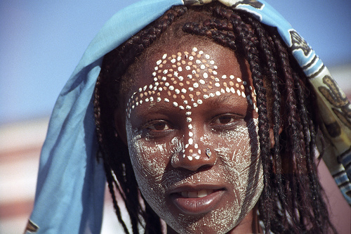
You will design a tattoo intended for yourself on a body part that is not covered by a conservative bathing suite (if in doubt, check with Mrs. Showalter).

Building Block(s):
- Creating Value with Ink
- Toning with Ink on Colouring Sheet

Process:
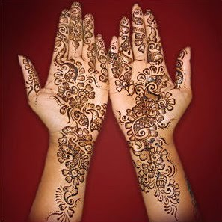
- Select and Visually Research a Cultural Adornment style. In your sketchbook attach images (at least 6) and analyse the style and how you would reproduce it. Make sure that you site your work.
- Choose one to three body parts you want to use as the site for your designs.
- Create three thumbnail sketches for one to three body parts. Please make sure that you are taking the site that you chose into consideration. Your tattoos should reinforce or reveal something about you.
- Choose your best design and enlarge it.
- Complete your drawing using pen and ink designs. You may use a combination of ink pen and pen-and-nib as your medium.
- You may choose to add colour beyond black and white.
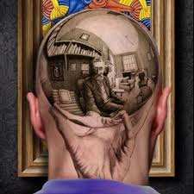 | 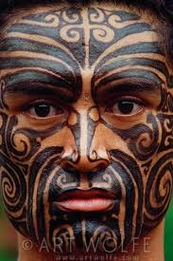 | 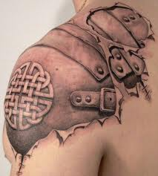 | 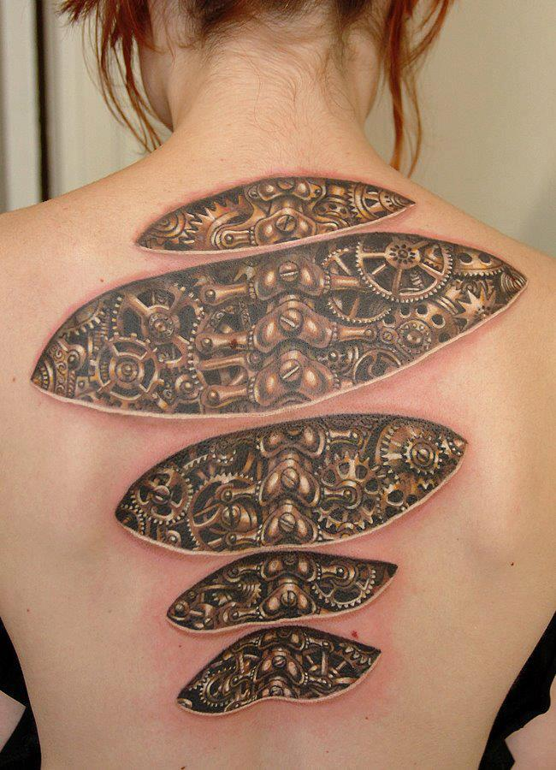
Points of Evaluation: Originality of Design, Body Part + Design, Pen and Ink Techniques, Time on Task, Attention to Detail

