Showalter
Clay Chalice
Chalice: (from Latin calix, cup, borrowed from Greek kalyx, shell, husk) is a goblet or footed cup intended to hold a drink. In general religious terms, it is intended for drinking during a ceremony. http://en.wikipedia.org/wiki/Chalice
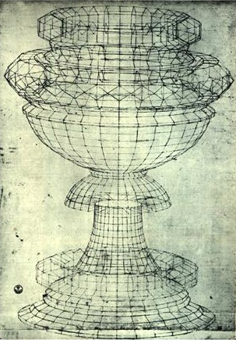
Your Challenge:
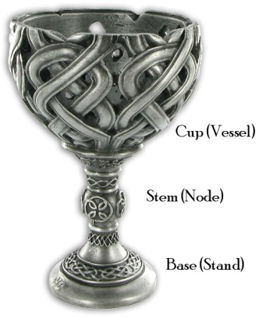
You will design and create a chalice out of clay. You may use several techniques including coil, pinch and/or slab to build your chalice. It must incorporate human, animal or vegetation elements (at least one) in your designs. You will make at least 2 areas of decoration

Anatomy of a Chalice:
Make sure that your designs have all three parts of the anatomy of a chalice.

Reference/Sources:
Use Google for more images and inspiration.

Preparation:
- Clay Hand-Building Presentation
- Clay Vocabulary
- Designing a Chalice (3 thumbnail sketches)
- Using Plasticine to practice hand-building techniques

Art Concepts:
Form, Positive and Negative Space, Balance, Variety, Unity, Repetition

Requirements for your Clay Chalice:
- Your design will have the 3 parts of chalice anatomy.
- You will incorporate at least 1 element (human, animal or plant) and 2 different decorations on your chalice.
- Your vessel will be at least 4” high.

- Make sure that you SCORE, SLIP and SEAL!!!
- Keep your clay covered in plastic at all times when you are not with working it.
- If you need more time to work on your Chalice, room 111 will be open from 3:00 to 4:00pm depending upon need.

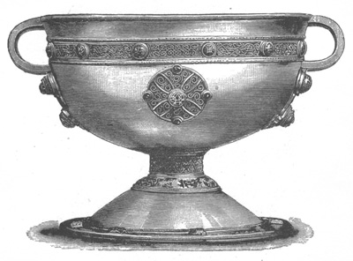 |  | 