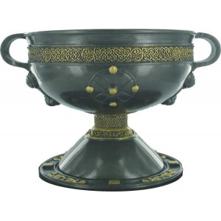
Evaluation: Clay Slab Box or Chalice
I completed (indicate which one) a Clay Slab Box or a Chalice.

How is clay different from the other media that you have used?
_______________________________________________________________________
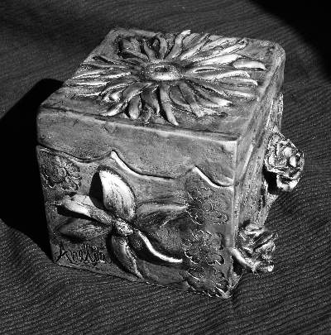
_______________________________________________________________________
_______________________________________________________________________
_______________________________________________________________________
_______________________________________________________________________
_______________________________________________________________________

What did you learn about clay? Do you see future applications for this medium? Do you like the results of your project? Explain your answer.
__________________________________________________________________
__________________________________________________________________
__________________________________________________________________
__________________________________________________________________
____________________________________________________________________________________________________________________________________________________________________________________________________________________________________________________________________________________________________________________________________________________

Points of Evaluation:
- Design/Composition (developed designs for my chosen project)
_____________________________________________________________________________________________________________________________________________________________________________________________________________________________________________________________________________________________________________________________________ Level _________

- Clay Construction (used either coil or slab with score, slip and seal)
_____________________________________________________________________________________________________________________________________________________________________________________________________________________________________________________________________________________________________________________________________ Level _________

- Application of Stain/Glaze (even coverage, skill in application)
_____________________________________________________________________________________________________________________________________________________________________________________________________________________________________________________________________________________________________________________________________ Level _________

- Use of Time (personal focus on the assignment and effective use of time.)
_____________________________________________________________________________________________________________________________________________________________________________________________________________________________________________________________________________________________________________________________________ Level _________

- Attention to Detail (working to your best ability in creating the best image possible.)
_____________________________________________________________________________________________________________________________________________________________________________________________________________________________________________________________________________________________________________________________________ Level _________

