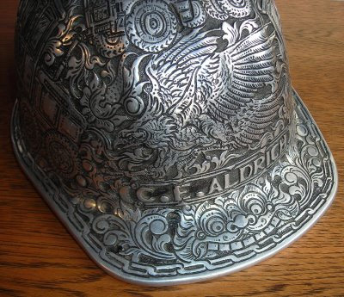
Showalter Name ________________
Evaluation: Hard Hat Project
There are two parts to this Final Evaluation; this reflection and an artist statement.

Part 1: Points of Evaluation:
- Subject Matter (idea(s) – what was your thought process to come-up with your idea?)
___________________________________________________________________________________________________________________________________________________________________________________________________________________________________________________________________________________________________________________________________________________________________________________________________________________________Student Level:__
- Composition (how did you combine and create your subject matter into a strong composition?)
___________________________________________________________________________________________________________________________________________________________________________________________________________________________________________________________________________________________________________________________________________________________________________________________________________________________Student Level:__
- Application of Medium (How well did you use the medium or layers of media – Skill)
___________________________________________________________________________________________________________________________________________________________________________________________________________________________________________________________________________________________________________________________________________________________________________________________________________________________Student Level:__
- Time on Task (personal focus on the assignment and effective use of time)
___________________________________________________________________________________________________________________________________________________________________________________________________________________________________________________________________________________________________________________________________________________________________________________________________________________________Student Level:__
- Attention to Detail (working to the best of your ability to create your best work)
___________________________________________________________________________________________________________________________________________________________________________________________________________________________________________________________________________________________________________________________________________________________________________________________________________________________Student Level:__

Part 2: Artist Statement
On a separate sheet of paper you will submit an artist statement (along with a digital file). Your artist statement will be structured in the following paragraphs:
Paragraph #1: Introduction of ideas (brainstorming, inspirations, etc. )  Paragraph #2: Composition – Arrangement of Subject Matter  Paragraph #3: Use of Media, Your Process, What you Learned…  Paragraph #4: How does your idea relate to you?  How successful is your finished work? Conclusion |  | Points of Evaluation:  Content (outlining creative process)  Spelling/Grammar (correct-Canadian)  Style (ease of reading and flow)  Editing (to the point, concise writing)

