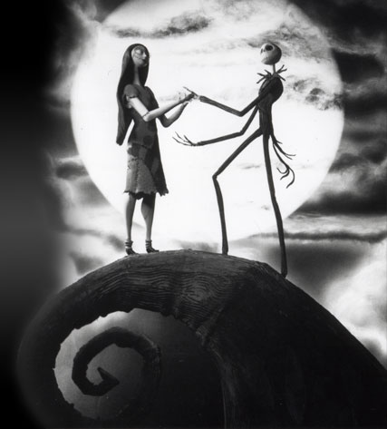
Evaluation: Nightmare at FMSS
- Which focused artist’s style most influenced your scratchboard image? What characteristics did you incorporate in your work? How did this alter the overall style to your work?
______________________________________________________________________________
______________________________________________________________________________
______________________________________________________________________________
______________________________________________________________________________
__________________________________________________________________________________________________________________________________________________________________________________________________________________

- How did working in the opposite direction to tone your work change your approach? How did you overcome this challenge? Be specific.
__________________________________________________________________________________________________________________________________________________________________________________________________________________________________________________________________________________________________________________________________________________________________________________________________________________________________________________________________________________________________________________________________________________

Evaluation Criteria:
Environment (the FMSS location you chose, proportion, perspective) ____________________________________________________________________________________________________________________________________________________________________________________________________________________________________________________________________________________________________________________________________________________________________________________________________________________________________ Level: _____

Composition (how you organize your image. Think framing, zooming, cropping and viewpoint.)
____________________________________________________________________________________________________________________________________________________________________________________________________________________________________________________________________________________________________________________________________________________________________________________________________________________________________ Level: _____

Style (capturing the dark, suspenseful styles from our inspiration artists shown above.) ____________________________________________________________________________________________________________________________________________________________________________________________________________________________________________________________________________________________________________________________________________________________________________________________________________________________________ Level: _____

Application of Media (use of line to create value in scratchboard)
____________________________________________________________________________________________________________________________________________________________________________________________________________________________________________________________________________________________________________________________________________________________________________________________________________________________________ Level: _____

Time on Task (personal focus on the assignment and effective use of time.)
____________________________________________________________________________________________________________________________________________________________________________________________________________________________________________________________________________________________________________________________________________________________________________________________________________________________________ Level: _____

Attention to Detail (working to your best ability in creating the best images possible.)
____________________________________________________________________________________________________________________________________________________________________________________________________________________________________________________________________________________________________________________________________________________________________________________________________________________________________ Level: _____

