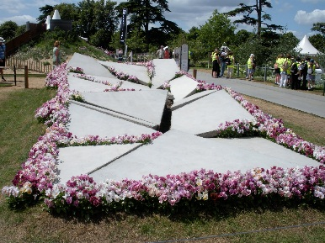
Name:
Evaluation: The Pansy Project

Points of Evaluation:
Compositions (how you organize your image. Think framing, zooming, cropping and viewpoint)
________________________________________________________________________________________________________________________________________________________________________________________________________________________________________________________________________________________________________________________________________________________________________________________________________________________________________________________________________________________________________________________________________________________________________________________________ Level: _____

Subject Matter (outline your main idea and how you showed it)
________________________________________________________________________________________________________________________________________________________________________________________________________________________________________________________________________________________________________________________________________________________________________________________________________________________________________________________________________________________________________________________________________________________________________________________________ Level: _____

Toning/Use of Acrylic Paint (how you created a full range of values from light to dark and acrylic techniques)
________________________________________________________________________________________________________________________________________________________________________________________________________________________________________________________________________________________________________________________________________________________________________________________________________________________________________________________________________________________________________________________________________________________________________________________________ Level: _____

Time on Task (personal focus on the assignment and effective use of time in and out of class)
________________________________________________________________________________________________________________________________________________________________________________________________________________________________________________________________________________________________________________________________________________________________________________________________________________________________________________________________________________________________________________________________________________________________________________________________ Level: _____

Attention to Detail (working to your best ability in creating the best image(s) possible.)
________________________________________________________________________________________________________________________________________________________________________________________________________________________________________________________________________________________________________________________________________________________________________________________________________________________________________________________________________________________________________________________________________________________________________________________________ Level: _____

What tips would you give to someone beginning this project? Why?
___________________________________________________________________________________________________________________________________________________________________________________________________________________________________________________________________________________________________________________________________________________________________________________________________________________________________________________________________________________________________________________________________________________________________________________________________________________________________________________________________________________________________________

