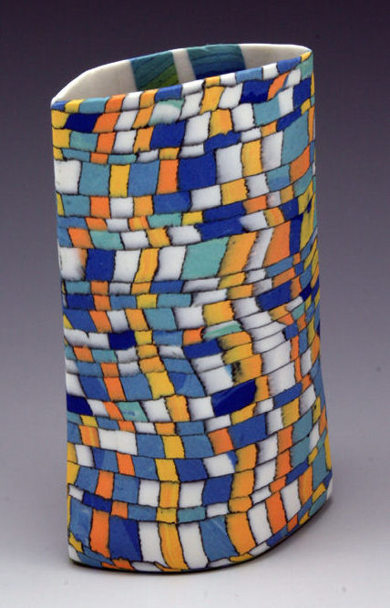
EVALUATION: Porcelain Clay Unit Name: ____________
Check List:
- Completed inspiration pages in Sketchbook
- Slump plate created with ‘cookies’
- Bowl using own techniques
- Free-form item(s)

Points of Evaluation:
Composition (Design of three objects – state approach for each)

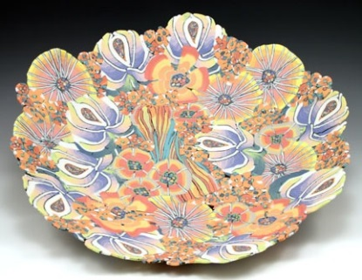
Medium (Use of Clay, slab techniques and polymer clay techniques)

Time on Task (effective use of time in and out of class)

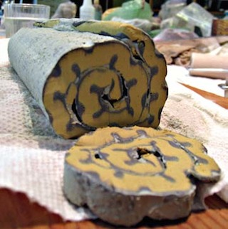

Attention to Detail (no clay crumbs, effective designs, etc.)

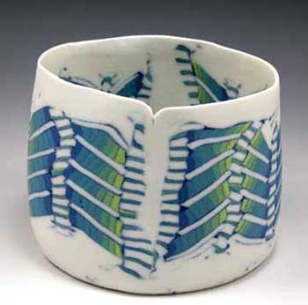
Surface Treatment (glazing, decoration, etc.)

Additional Questions:
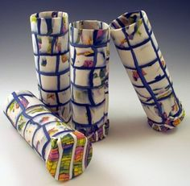
Finally, what went well? What challenges did you face? How did you overcome them? What 2 tips would you give to someone beginning this assignment?

Please complete your answers to all of the above points using a word document program.

