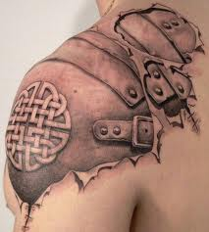
Evaluation: Body Ornamentation, Tattoo Design
What type(s) of body ornamentation do you do to your body to make you more attractive? Why?
_________________________________________________
_________________________________________________
_________________________________________________
_________________________________________________
_________________________________________________
_________________________________________________
_________________________________________________
What other types of body ornamentation do you find attractive? Why? Would you do this to your body? Why or why not? ______________________________________________________________________
________________________________________________________________________________________________________________________________________________________________________________________________________________________________________________________________________________________________________________________

Points of Evaluation:
Originality of Design/Composition (influence from an existing culture is clear – identify it)
____________________________________________________________________________________________________________________________________________________________________________________________________________________________________________________________________________________________________________ Level _______
Body Part + Realism (anatomically correct, proper proportions)
____________________________________________________________________________________________________________________________________________________________________________________________________________________________________________________________________________________________________________ Level _______
Pen and Ink Techniques (use of techniques & creating value)
____________________________________________________________________________________________________________________________________________________________________________________________________________________________________________________________________________________________________________ Level _______
Time on Task (good use of class time, staying on task, meeting deadlines)
____________________________________________________________________________________________________________________________________________________________________________________________________________________________________________________________________________________________________________ Level _______
Attention to Detail (overall the work is completed to a high quality)
____________________________________________________________________________________________________________________________________________________________________________________________________________________________________________________________________________________________________________ Level _______

