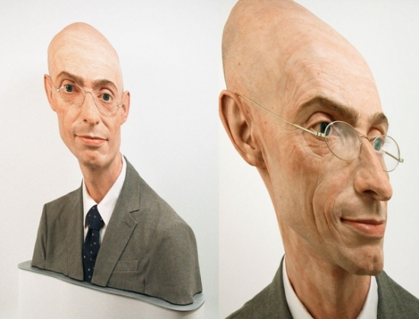
Evaluation: Stretched Portrait
How did you design your stretched grid? How does this add interest to your original photograph?

What did you learn about drawing with graphite? Do you like the results of this medium? How could you improve? Could this medium be effective combined with another medium? If so, what?

Points of Evaluation: Please explain how you incorporated the following...
- Stretched Grid (altered grid to stretch, squish, etc to make your face really interesting)
Level:

- Scaled Enlargement (use of photograph to realistically enlarge to new grid)
Level:

- Application of Medium (toning with graphite, range of values)
Level:

- Time on Task (personal focus on the assignment and effective use of time.)
Level:

- Attention to Detail (working to your best ability in creating the best image possible.)
Level:

