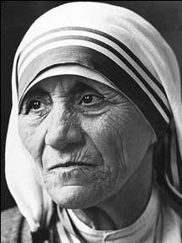
Name:
Evaluation: Humanitarian Watercolour Painting
What is a humanitarian? Who did you choose? Please explain why.
___________________________________________________________
___________________________________________________________
___________________________________________________________
___________________________________________________________
___________________________________________________________
___________________________________________________________

How does combining text and images add interest to an artwork? What quote did you choose to incorporate into your composition? Why?
______________________________________________________________________________________________________________________________________________________________________________________________________________________________________________________________________________________________________________________________________________________________________________________________________

Points of Evaluation: Please explain how you incorporated the following...
- Portrait (good choice of a humanitarian, recognizable, etc)

Level:

- Composition & Quote (sophisticated incorporation of a quote within the composition)
Level:

- Application of Medium (toning with watercolour paint, range of values, colour scheme that enhances the overall message of the humanitarian to the viewer)
Level:

- Time on Task (personal focus on the assignment and effective use of time.)
Level:

- Attention to Detail (working to your best ability in creating the best image possible.)
Level:

