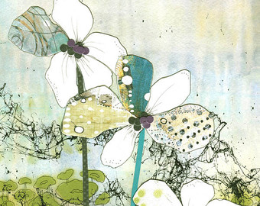
Name:
Evaluation: 2 Point Perspective Drawing
How does layering images add interest to an artwork?
_____________________________________________________
_____________________________________________________
_____________________________________________________
_____________________________________________________
What did you learn about painting with watercolour? Do you like the results of this medium? Why or why not? Could this medium be effectively combined with another medium? If so, what?
______________________________________________________________________________________________________________________________________________________________________________________________________________________________________________________________________________________________________________________________________________________________________________________________________

Points of Evaluation: Please explain how you incorporated the following...
- Composition (use of source material to develop a sophisticated composition; enlarge, layer, intersections.)

Level:

- Colour Scheme (use of a colour scheme that enhances and highlights objects)
Level:

- Application of Medium (toning with watercolour paint, range of values)
Level:

- Time on Task(personal focus on the assignment and effective use of time.)
Level:

- Attention to Detail (working to your best ability in creating the best image possible.)
Level:

