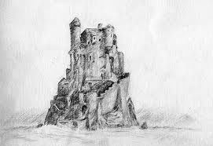
Grade 11
Showalter

Fantasy Drawing & Painting
Your Challenge:
You will research several different topics and combine this inspiration with 2 point perspective to create a drawing that will be painted using watercolour. Think about the movie set design for Lord of the Rings, Harry Potter, Star Wars, etc.
Demonstrations:
- Several 2 point perspective drawing components (sketchbooks)
- Watercolour Toning
The Process:
- You will choose an Art era to research their architectural style. In your sketchbook/binder, consolidate your research which will include images, sketches, your analysis and your thought process to defining the characteristics of the style you have identified. (Think: elements and principles of design) This research should take at least one well-researched and thoughtful pages.
- Roman | - Greek | - Romanesque | - Gothic
- High Gothic | - British Gothic | - Renaissance | - Art Deco
- Art Nouveau | - Steam Punk | - Mid 1930s-50s | - Islamic
- Any distinctive visual culture with a strong architectural style
- Choose an artist who is/was extremely proficient in 2 point perspective. Select one image (include in your sketchbook) and analyze how he/she excelled creating the perspective shown. Choose one of the following artists or choose another
- DaVinci, Michelangelo, Raphael, Escher, Alan Lee, John Howe, Durer.
- Use your device and navigate through the online resource listed below. Make notes in your sketchbook. http://www.webexhibits.org/sciartperspective/index.html (Science and Art of Perspective)
- Create 3 quick thumbnail sketches planning out three different ideas that show you were inspired by either the era of architecture or artist you selected. Choose the best one to enlarge using 2 point perspective as accurately as possible.
- Design your 2 point perspective drawing that draws inspiration from your research from above. Your drawing will include the following:
- At least 5 circles
- A staircase of at least 5 steps
- At least one triangle
- At least 3 telephone pole approaches with at least 3 units in each series.
- Your drawing will be evaluated at this point.
- Choose the best part of your drawing and transfer to watercolour paper.
- Paint using a monochromatic colour scheme.
- Mat with a window mat and submit.
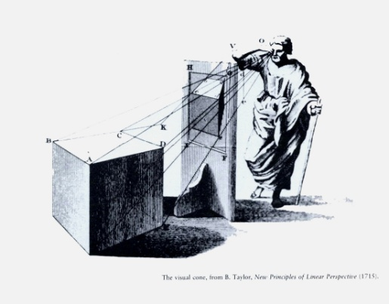 | 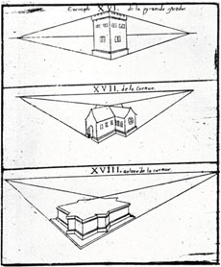 | 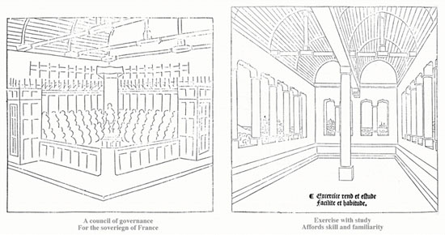

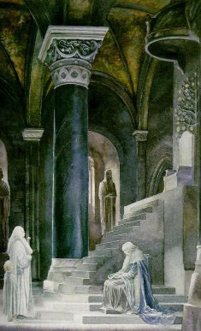 | 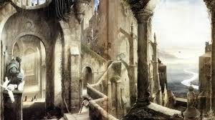 | 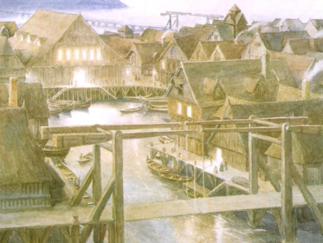
Example:
Alan Lee and John Howe were the Art Designers of the Lord of the Rings trilogy.
Lee worked on designs for architecture, the first being Helm's Deep,^{[3]} as well as the Elven realms, Moria, Edoras, and Minas Tirith, and although Howe primarily designed armour and the forces of evil (see below), he contributed with Bag End, Minas Morgul, Cirith Ungol and the Barad-dûr. Lee also applied a personal touch by painted imagery in Rivendell, such as the one of Isildur removing the One Ring from Sauron, as well as tapestries in Edoras. There are real life influences to Middle-earth: Rivendell is "a cross between a Japanese Temple and Frank Lloyd Wright",^{[6]} and Minas Tirith takes influence from Mont Saint-Michel, St Michael's Mount and Palatine Chapel in Aachen. The City of the Dead takes after Petra, Jordan, and the Grey Havens were inspired by the paintings of J. M. W. Turner.^{[4] Wikipedia.com}
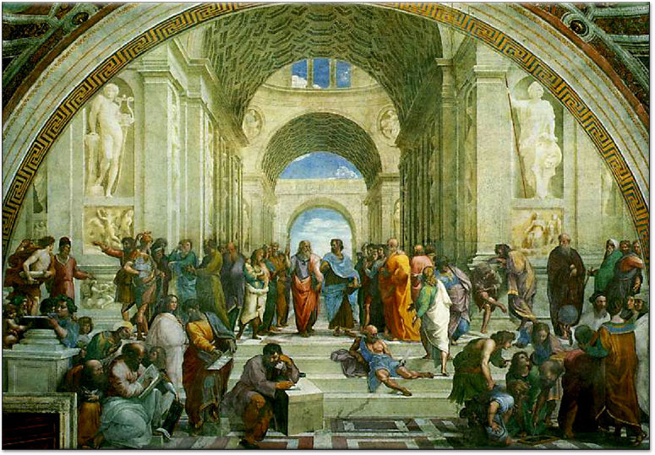
Raphael, School of Athens, 1510. Fresco.

