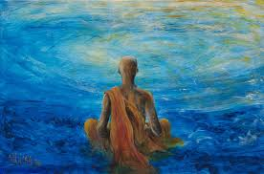
AVI 3M Trivedi/Showalter
My Nirvana
(images.fineartamerica.com/images-medium-large-5/meditation-nik-helbig.jpg)
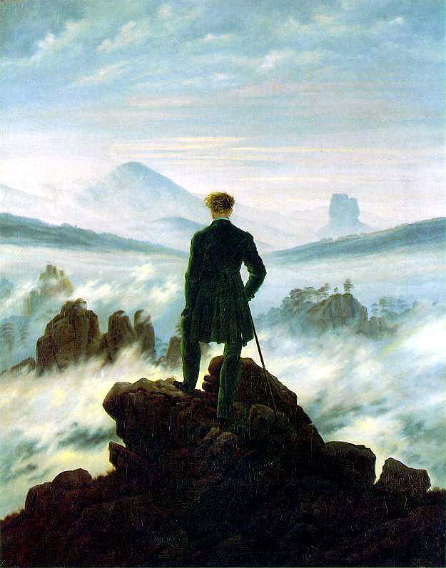
The act of making Art has been with humans since the beginning. Artists have an intimate connection with the objects that they design, as they create them and how they are used when complete. This connection with the making of art could be considered a form of personal, contemplative and/or meditative expression. Art is unique as it communicates on many levels through its life or existence. Artists are able to share their inner experiences and emotions. It can be therapeutic as it can bring calming feelings to the artist and be a visual channel to share one’s thoughts and emotions.

Your Challenge:
You will design a real or an imaginary landscape where you feel at peace, see the third definition of nirvana below. Your landscape should be a place that brings you positive energy and happiness. You will also paint yourself in the foreground of the landscape in a position that you feel comfortable. You will position yourself to look into the landscape with your back facing the viewer (think of Wanderer Above the Sea of Fog by Casper David Friedrich, or the image above).
www.bc.edu/bc_org/avp/cas/his/CoreArt/art/rom_fri_wand.html

nir·va·na [nir-vah-nuh, -van-uh, ner-] noun
1. ( often initial capital letter ) . Pali nibbana. Buddhism. freedom from the endless cycle of personal reincarnations, with their consequent suffering, as a result of the extinction of individual passion, hatred, and delusion: attained by the Arhat as his goal but postponed by the Bodhisattva.
2.( often initial capital letter ) Hinduism. salvation through the union of Atman with Brahma; moksha.
3. a place or state characterized by freedom from or oblivion to pain, worry, and the external world.
dictionary.reference.com/browse/nirvana
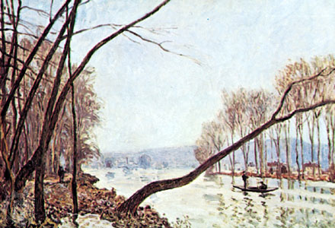
From the Veils of Time: Aerial Perspective
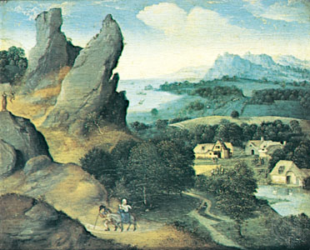
“A method of creating the illusion of depth, or recession, in a painting or drawing by modulating colour to simulate changes effected by the atmosphere on the colours of things seen at a distance. Although the use of aerial perspective has been known since antiquity, Leonardo da Vinci first used the term aerial perspective in his Treatise on Painting, in which he wrote: “Colours become weaker in proportion to their distance from the person who is looking at them.” It was later discovered that the presence in the atmosphere of moisture and of tiny particles of dust and similar material causes a scattering of light as it passes through them, the degree of scattering being dependent on the wavelength, which corresponds to the colour, of the light. Because light of short wavelength—blue light—is scattered most, the colours of all distant dark objects tend toward blue; for example, distant mountains have a bluish cast. Light of long wavelength—red light—is scattered least; thus, distant bright objects appear redder because some of the blue is scattered and lost from the light by which they are seen.

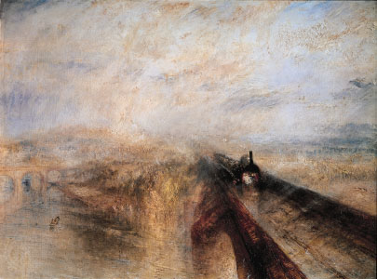
The intervening atmosphere between a viewer and, for example, distant mountains, creates other visual effects that can be mimicked by landscape painters. The atmosphere causes distant forms to have less distinct edges and outlines than forms near the viewer, and interior detail is similarly softened or blurred. Distant objects appear somewhat lighter than objects of similar tone lying closer at hand, and in general contrasts between light and shade appear less extreme at great distances. All these effects are more apparent at the base of a mountain than at its peak, since the density of the intervening atmosphere is greater at lower elevations.

Examples of aerial perspective have been found in ancient Greco-Roman wall paintings. The techniques were lost from European art during the “Dark” and Middle Ages and were rediscovered by Flemish painters of the 15th century (such as Joachim Patinir), after which they became a standard element in the European painter’s technical vocabulary. The 19th-century British landscape painter J.M.W. Turner made perhaps the boldest and most ambitious use of aerial perspective among Western artists. Aerial perspective was used with great sophistication and pictorial effectiveness by Chinese landscape painters from about the 8th century on.”
Source of Images and content: www.britannica.com/EBchecked/topic/7229/aerial-perspective

Sketchbook Assignments:
- Drawing and Music (1 final sketch + reflection)
- Landscape Dissection (3 photographs)
- Elements relating to peace: Colour, Line, Shape, Value, Texture
- Figure Drawing with Focus on Position

The Process:
- Refer to your last sketchbook assignment that you used to create landscapes that show inner peace. Look at your responses or points that you made for each element of design. In your sketchbook for this assignment, list the elements again.
- Colour, line, shape, value and texture
If you were happy with the choices that you made on the original sheet then transfer this content to your sketchbook. If you would like to alter how you want to use the elements of design, make the changes in your sketchbook. (You are determining the colour scheme and overall ‘feel’ that your finished work will have.)
- Decide on how you will pose yourself. What pose do you find the most comfortable? Work with a partner and use photographic devices to capture you in at least 3 poses of comfort and/or contemplation that you will use to experience the alternative reality that you will create. Print out these images and glue them into your sketchbook.
- Create three thumbnail drawings that include the following information:
- Landscape elements: foreground, middle ground and background.
- A pose of yourself in a contemplative and/or comfortable position, back to viewer.
- Use the Elements of Design choices that you made in step one.
- Keep in mind of what areas you want light, dark, detailed, blurred, and so forth.
- Consider the effect of aerial perspective as you create your compositions.
- Choose your best thumbnail sketch and enlarge it.
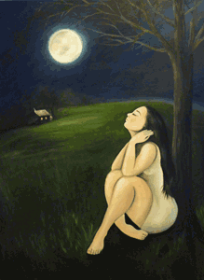
Points of Evaluation:
- Composition (Landscape Components, Aerial Perspective and Proportional Pose – Self Portrait)
- Elements of Design (Visualization of Peace, Balance and Happiness)
- Application of Media (Appropriate and Sophisticated Use of Media to Achieve Desired Effect)
- Time on Task (Positive Use of Class Time Showing Personal Focus and Time Management)
- Attention to Detail (Working to Your Best Ability to Create the Best Image Possible)

Take Creative Risks and Try Something New!
Images: www.challengefuture.org, www.artbuffet.org, www.media-cache-ec0.pinimg.com, www.oilpaintings-sales.com, www.insoonart.com
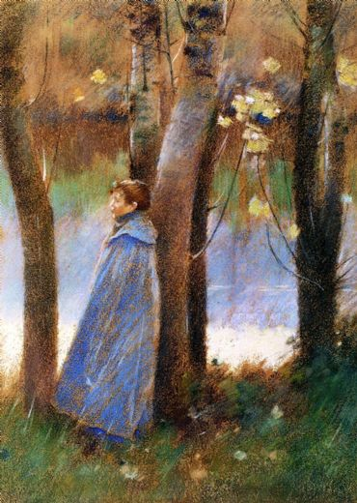
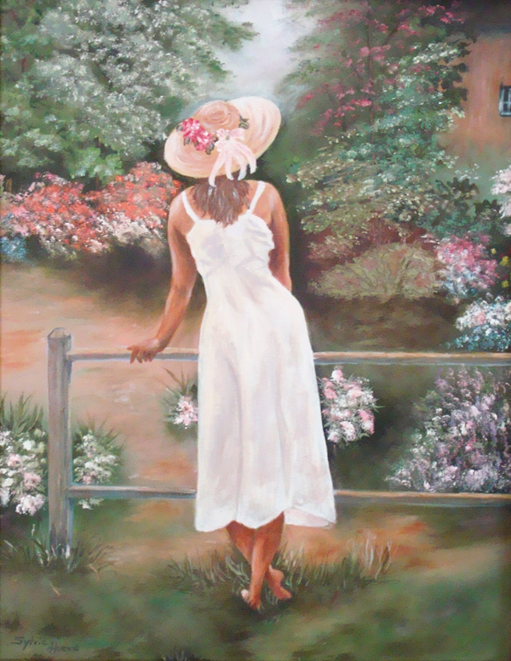
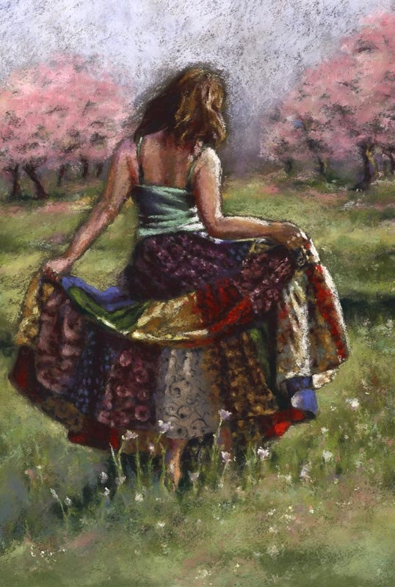
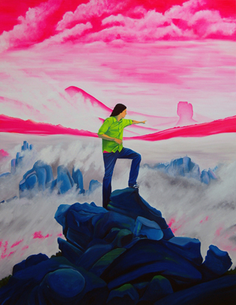

Evaluation: My Nirvana
(image: http://www.jaspaljandu.com/x_photos/large_LGBL1001_033a42.jpg)
What are some things that you do to bring peace, happiness and balance to your life? Please explain.
When you think about your inner peace, how do you imagine it? Please be specific.

Points of Evaluation: Please explain how you incorporated the following,
- Composition (Landscape Components and Proportional Pose – Self Portrait)
Student Level:______

- Composition and Elements of Design (Visualization of Peace, Balance and Happiness)
Student Level:______

- Application of Medium (Appropriate and Sophisticated Use of Media to Achieve Desired Effect)
Student Level:______

- Time on Task (Positive Use of Class Time Showing Personal Focus and Time Management)
Student Level:______

- Attention to Detail (Working to Your Best Ability to Create the Best Image Possible)
Student Level:______

