Visual Arts Showalter
Nightmare in FMSS: The Inspirations

Edward Gorey was a prolific illustrator who produced many books/comic books and images. Much of his work explored ominous themes. He inspired many other artists and gained a cult following.
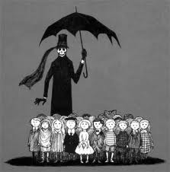 | 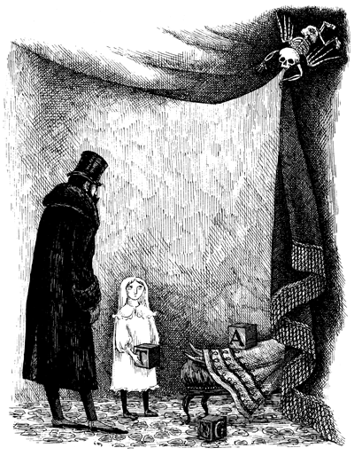 | 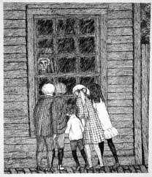 | 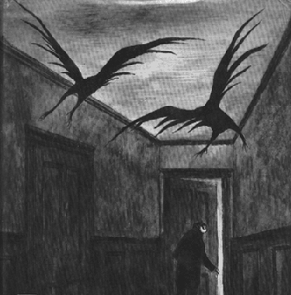
Many artists have experimented with dark subject matter. Comic book artists, like Bernie Wrightson, use extreme light & shadow with extreme success that explore suspense and suggest ideas of horror. Gris Grimly is another artist who explores these ideas of other dark, places with exotic, other-worldly characters.
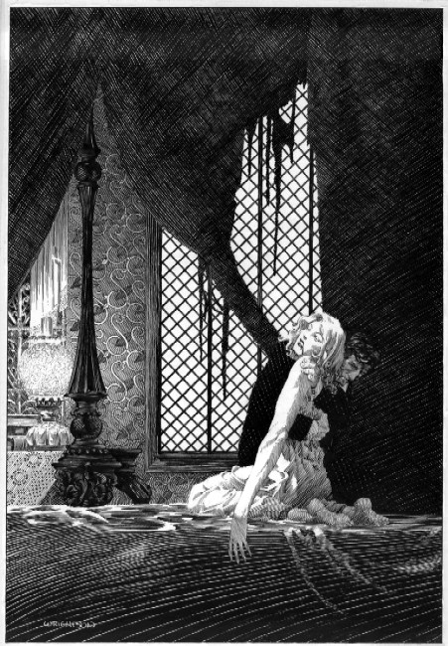 | 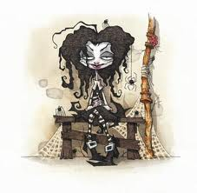 | 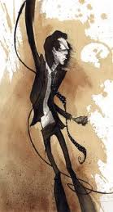 | 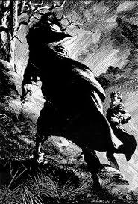

The art of Tim Burton is highly recognizable for its stylized characters and dark edge. He is an acclaimed artist, producer and director of many popular films such as; BeetleJuice, Edward ScissorHands, Nightmare before Christmas, Charlie and the Chocolate Factory and the Corpse Bride to name a few. The art work he produces create an alternative, imaginative world that is psychologically charged like a nightmare.
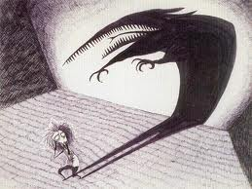 | 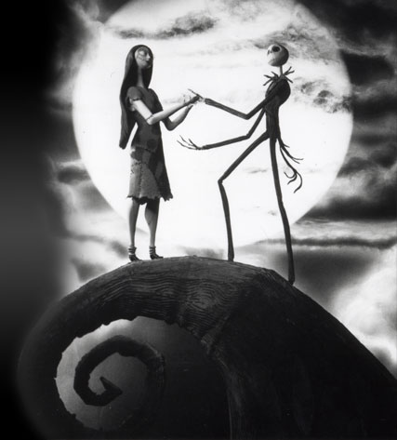 | 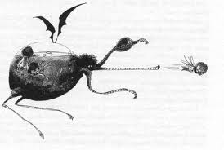

Recently, other art genres and artists have been influenced by Burton’s style that include specifically the Neil Gaiman film, Coraline and the Wii game called, World of Goo.
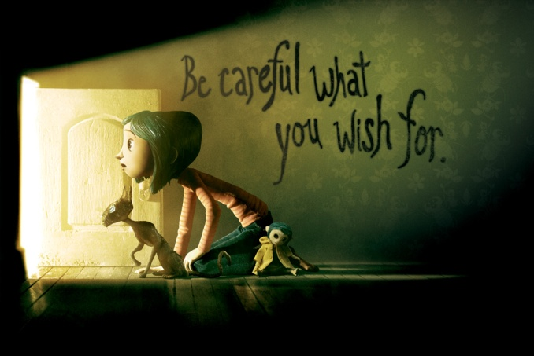 | 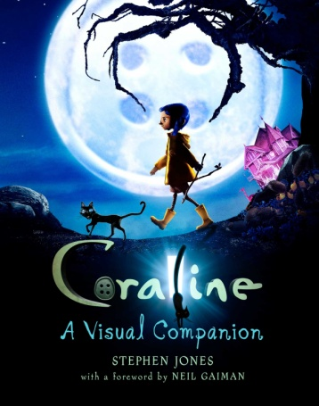 | 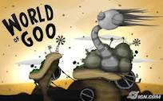
These artists have all drawn inspiration from artists like Albrecht Durer (1471 to 1528), a German printmaker. His art focused on symbols and allegories in the creation of his compositions. There is a strong sense of line and perspective in his work.
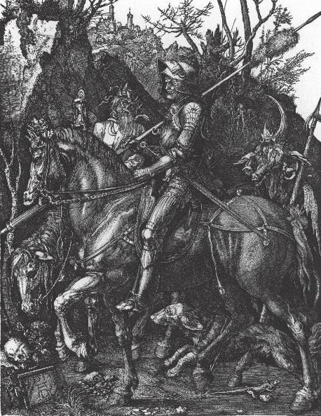 | 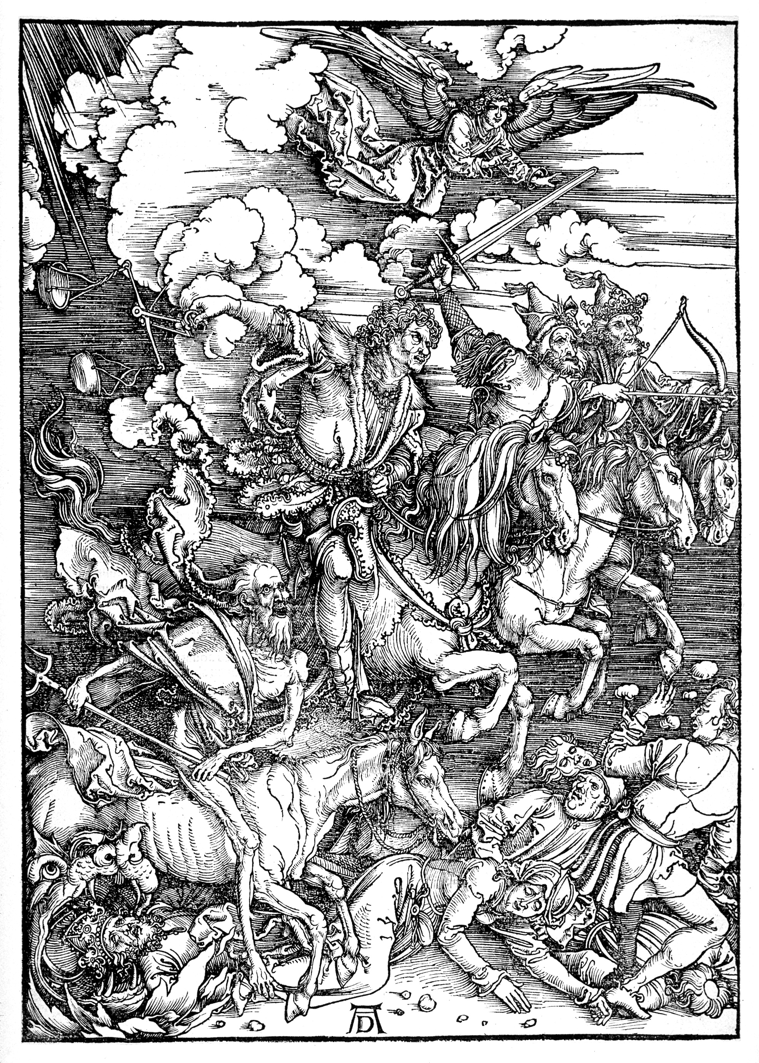 | 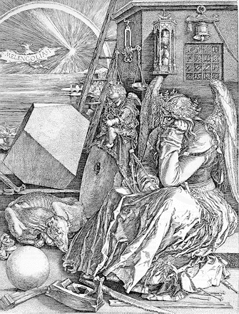
Albrecht Durer. The Knight, Death and The Devil, engraving, 1513 | Albrecht Durer. The Four Horsemen of the Apocalypse, Death, Famine, Pestilence and War, engraving, 1498. | Albrecht Durer. Melancholia, engraving, 1514.
Lastly, Albert Hitchcock (1899-1980), a film director, continues to influence generations of artists in the art of suspense, development of psychological tension, story-telling and subtle or implied horror. He collaborated with a graphic designer called Saul Bass. Bass created countless movie posters that capture these ideas using unusual, highly graphic and minimalist approaches that have entred our popular culture.
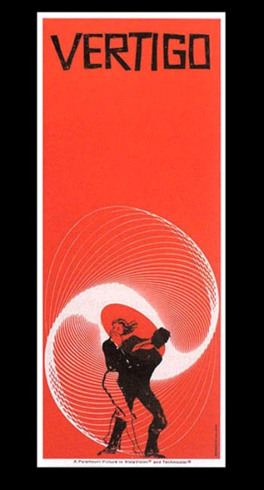 | 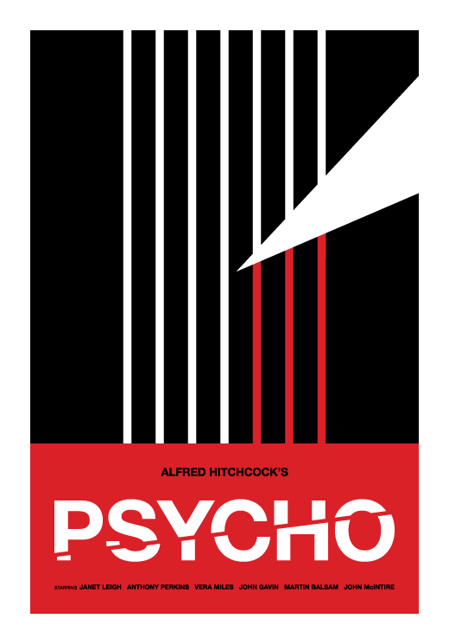 | 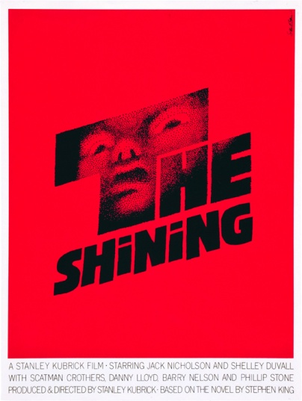 | 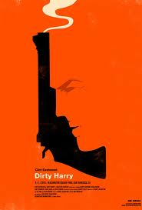 | 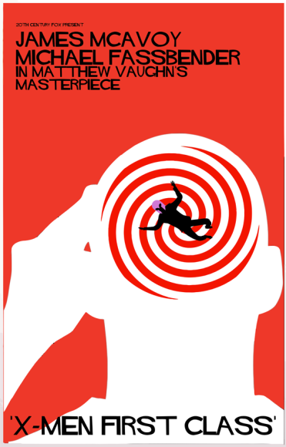

Hitchcock heavily rely upon storyboarding; every single shot for each movie was hand-drawn before filming...
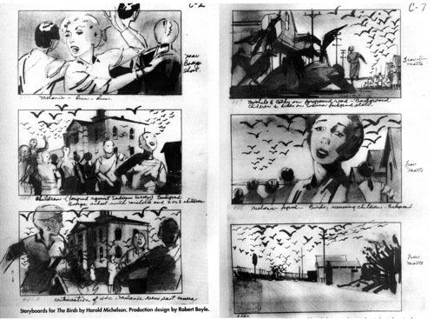 | 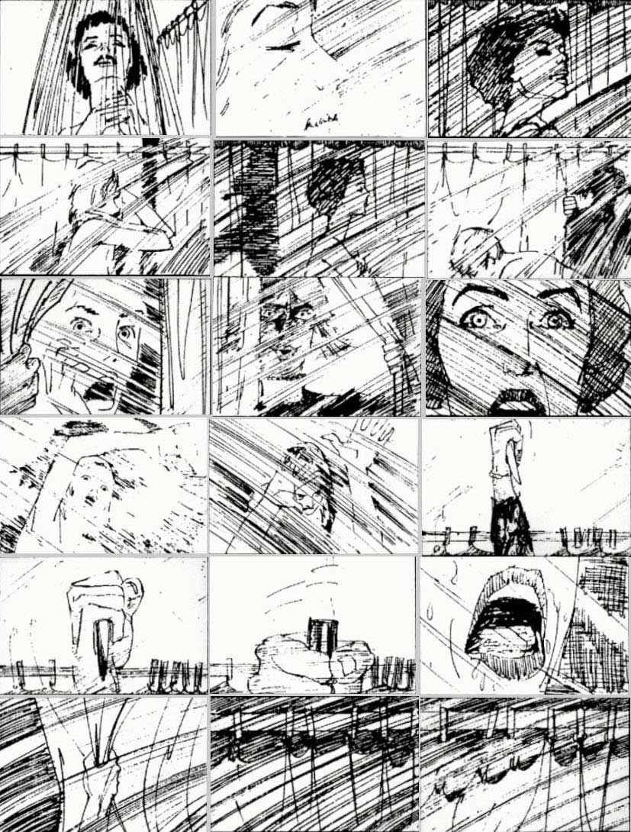 | 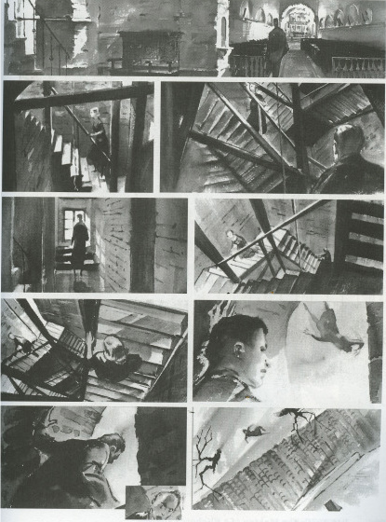
Storyboard by Harold Michelson for The Birds, 1963. | Storyboard by Saul Bass for Psycho, 1960. | Vertigo, 1958.

Nightmare in FMSS: The Other World
Your Challenge:
You will choose a location at FMSS and alter it so that there is the subtle suggestion of menace, heightened tension, psychologically charged or something that is not quite right... You will use a scratchboard with a focus on line quality to complete this work. This drawing will used a highly developed degree of light and shadow. Think to yourself, “what is being hidden or revealed?” Examine the above inspiration artists to determine how they get these qualities and apply them to your work.
The Process:
- Choose three locations in FMSS. Create drawings of these spaces and/or use a camera to document this space using extreme viewpoints.
- You will design three strong thumbnail sketches, one for each location, that incorporate strong composition. Refer to Composition Handout. Think about pose, proportion, view point, anatomy and developing the menacing tone your drawing will need.
- Choose your best design and enlarge it.
- You will use scratchboard to complete this drawing. Refer to your ‘Creating Value with Line’ demo. This drawing is about line and detail. You will need to engage and invest a great deal of time into the finished work to achieve the aims of this work.
- Mat your work to hand it in.
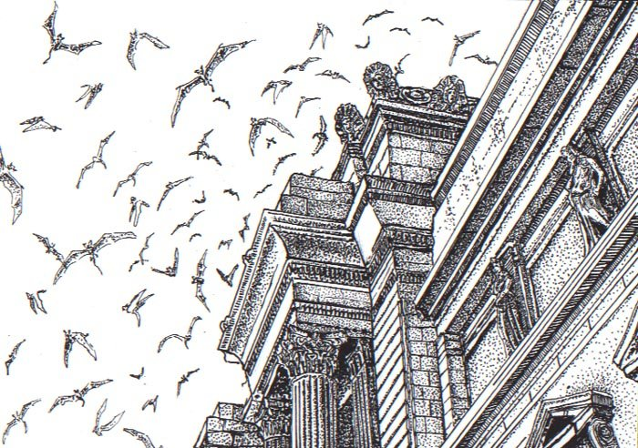
Evalutation:
- Environment (the FMSS location you chose, proportion, perspective)
- Composition (how you organize your image. Think framing, zooming, cropping and viewpoint.)
- Style (capturing the dark, suspenseful styles from our inspiration artists shown above.)
- Application of Media (use of line to create value)
- Time on Task (personal focus on the assignment and effective use of time.)
- Attention to Detail (working to your best ability in creating the best image possible.)

- Artist, Roxanne Karr

