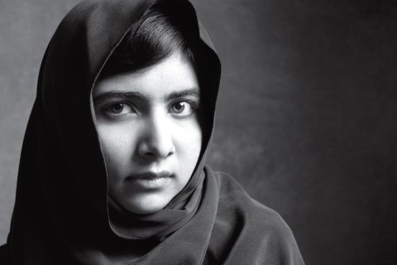
Showalter
People Helping People:
Extra-Ordinary Humanitarian Watercolour Painting
(Malala Yousafzai, b. 1997, http://time100.time.com)
Humanitarian Defined:
In its most general form, humanitarianism is an ethic of kindness, benevolence, and sympathy extended universally and impartially to all human beings. Humanitarianism has been an evolving concept historically but universality is a common element in its evolution. No distinction is to be made in the face of suffering or abuse on grounds of gender, sexual orientation, tribe, caste, age, religion, or nationality.
Humanitarianism can also be described as the acceptance of every human being for plainly just being another human, ignoring and abolishing biased social views, prejudice, and racism in the process, if utilized individually as a practiced viewpoint, or mindset.
http://en.wikipedia.org/wiki/Humanitarianism

Your Challenge:
You will choose a person, living or past, whom you feel embodies the above definition of a humanitarian. You will research how they helped others, find several images of the person and quotes that support your choice. Finally, you will design a composition that combines a portrait of the person as well as one highly pertinent quote by them. You will then create a watercolour painting.

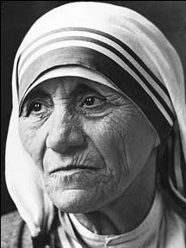 | 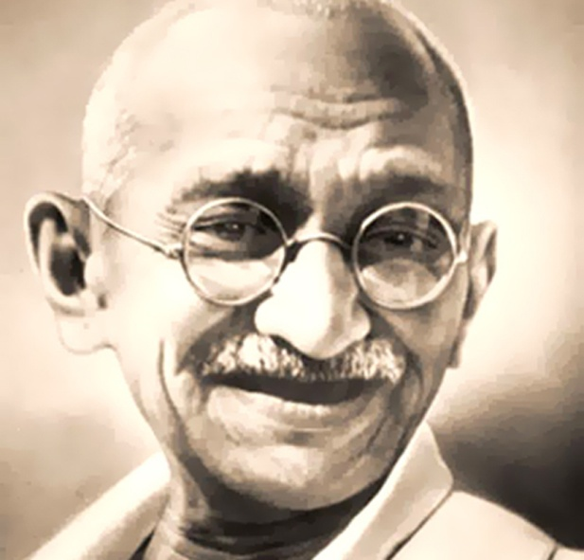 | 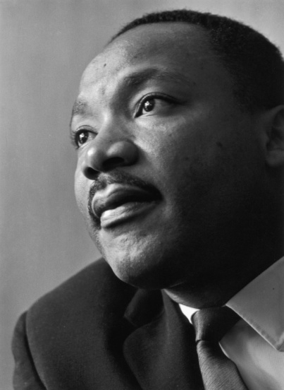 | 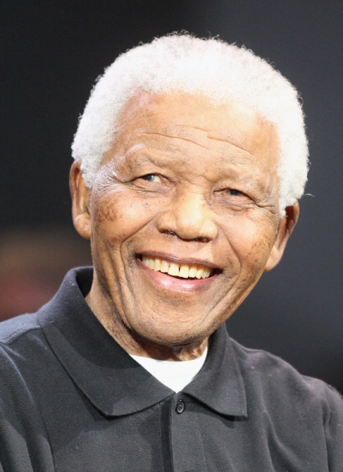
Mother Teresa, 1910-1997  http://www.spiritandsong.com/articles/13773 | Mahatma Gandhi, 1869-1947  http://www.thethrillionaire.com/blog/what-we-can-learn-from-gandhi/ | Martin Luther King, Jr, 1929-1968 http://ojeano.blogspot.ca/2011/01/happy-martin-luther-king-jrs-birthday.html | Nelson Mandela, 1918-2013  http://meritocracyparty.org/2013/12/nelson-mandela-fight-equal-opportunities/
Reference/Demonstrations:
- Humanitarian Class/Small Group Brainstorm
- Composition Reference Sheet
- Watercolour Demonstration & Watercolour Video
- 3 Thumbnail Sketches

The Process:
- Brainstorm what the word Humanitarian means to you in your sketchbook. In a small group, share your viewpoint with each other. Alter &/or add to your initial thoughts.
- With a partner or in a small group, discuss individuals who you feel are humanitarians. Use your device(s) to research. Create a common list. Post on blackboard.
- Individually choose three from the common list or do more research to determine 3 people who you support your definition. (You will explain your choice.) Research at least three quotes made by this person and copy them into your sketchbook.
- You will create 3 thumbnail designs that incorporate a person and a quote made by them.
- Choose the best thumbnail design and enlarge it before transferring it to watercolour paper.
- Develop a colour scheme that you will use with your composition. How will you emphasize your overall composition? Try it out on your best thumbnail to see if it works.
- Use watercolour to complete your work.
- You may add another medium if it will enhance your composition
- Mat your work and submit it with the Response Journal.

Points of Evaluation:
- Portrait (good choice of a humanitarian, recognizable, etc)
- Composition & Quote (sophisticated incorporation of a quote within the composition)
- Application of Medium (toning with watercolour paint, range of values, colour scheme that enhances the overall message of the humanitarian to the viewer)
- Time on Task (personal focus on the assignment and effective use of time.)
- Attention to Detail (working to your best ability in creating the best image possible.)

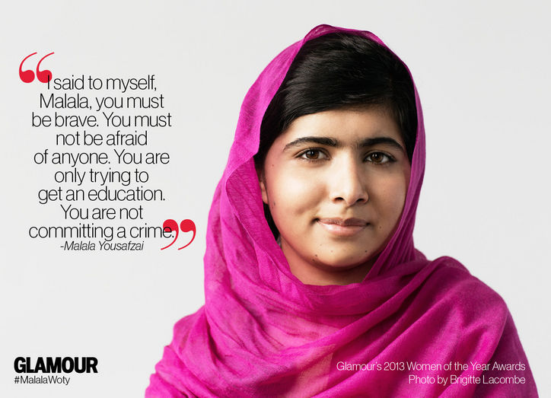
www.glamour.com

A note concerning the above poster: For your composition, you need to incorporate the quote and portrait in a much more sophisticated, creative way!

