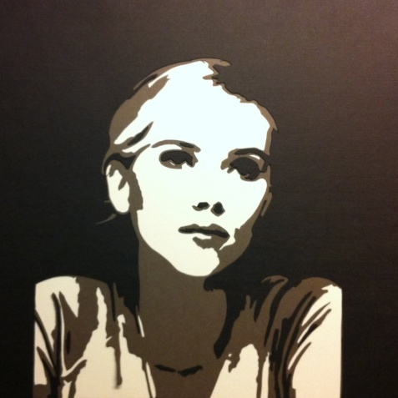
Evaluation: Stencilled Self-Portrait
How is stencilling different from the other mediums that you have used?
_______________________________________________________________________
_______________________________________________________________________
_______________________________________________________________________
_______________________________________________________________________
_______________________________________________________________________
_______________________________________________________________________

What did you learn about stencilling? Do you see future applications for this medium? Do you like the results of this medium? Please explain your answer. ________________________________________________________________________________________________________________________________________________________________________________________________________________________________________________________________________________________________________________________________________________________________________________________________________________________________________________________________________________________________________________________________________________________________________________________________________________________________________________________________________________________________________________________________________________________________________________________________________

Points of Evaluation:
- Self-Portrait and Name (Proportion, anatomically correct, recognizable portrait/signature)
_____________________________________________________________________________________________________________________________________________________________________________________________________________________________________________________________________________________________________________________________________________________________________________________ Level _________

- Composition (Positive/Negative space, cutting, to create a balanced composition)
_____________________________________________________________________________________________________________________________________________________________________________________________________________________________________________________________________________________________________________________________________________________________________________________ Level _________

- Application of Medium (Even application of paint, stippled, blending of colours)
_____________________________________________________________________________________________________________________________________________________________________________________________________________________________________________________________________________________________________________________________________________________________________________________ Level _________

- Time on Task(personal focus on the assignment and effective use of time.)
_____________________________________________________________________________________________________________________________________________________________________________________________________________________________________________________________________________________________________________________________________________________________________________________ Level _________

- Attention to Detail (working to your best ability in creating the best image possible.)
_____________________________________________________________________________________________________________________________________________________________________________________________________________________________________________________________________________________________________________________________________________________________________________________ Level _________

