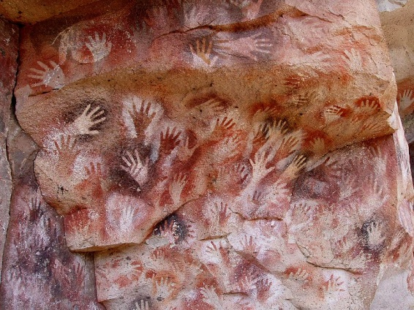
AVI 2O
Showalter
Stencilled Self-Portraits
The Inspiration:
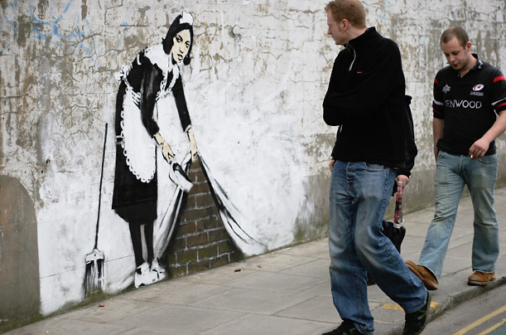
Stencilling is one of the oldest forms of art. Prehistoric humans stencilled their hands that serves as a visual record of their lives in several regions in the world. The image to the left is from a cave in Argentina. Through the centuries, stencilling has been used in many countries for different purposes. Today, there has been a resurgence of stencilling being used by urban graffiti artists. Banksy, the most influential graffiti artist from the UK, has elevated stencilling to an art-form that explores contemporary social issues. What does the image on the right say to you? For more information about Banksy, do a general search on google or check out this site, http://jerzygirl45.wordpress.com/art-gallery/banksy/

Your Challenge:
You will create a self-portrait that includes both your face and your name.

The Process:
- Using a mirror, draw your portrait. While you are drawing, Think about proportion and making your drawing as anatomically correct as possible.
- Incorporate your name in the design of your portrait using cursive.
- Transfer your drawing onto black Bristol board.
- You will now remove at least 50 percent of the space. Using an X-acto knife, cut out parts of the composition. Remember, that you want to end up with a balanced composition so you shouldn’t just cut on one half.
- Practice stencilling using paper. When you apply the paint, you need to have only a very small amount on the brush and stipple it on using short, vertical motions. You can play with blending 2 or more colours to experiment with techniques and effects.
- You will stencil your image onto black fabric using metallic paints. You will submit one paper stencil to be evaluated along with the fabric image.

Points of Evaluation:
- Self-Portrait and Name (Proportion, anatomically correct, recognizable portrait/signature)
- Composition (Positive/Negative space, cutting, to create a balanced composition)
- Application of Medium (Even application of paint, stippled, blending of colours)
- Time on Task(personal focus on the assignment and effective use of time.)
- Attention to Detail (working to your best ability in creating the best image possible.)

