AWM2O0 Showalter/Stratford
Surrealist Landscape Painting

sur·re·al·ism/səˈrēəˌlizəm/

Noun : A 20th Century era (time) in art and literature that sought to release the creative potential of the unconscious mind.

The Inspiration:

The Surrealist artists experimented with combining unusual objects in unlikely backgrounds. They were really interested in how human minds work, especially dreams and nightmares. Many artists today continue to play with the viewer’s perception and create images that have visual twists.
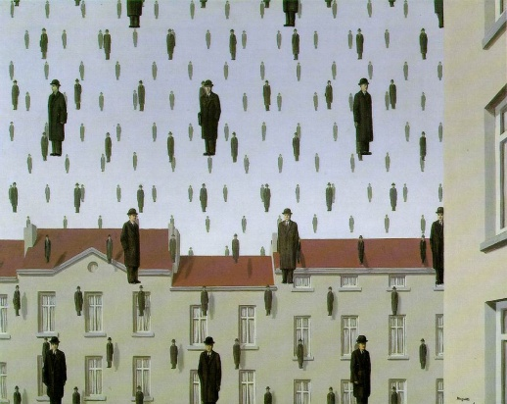 | 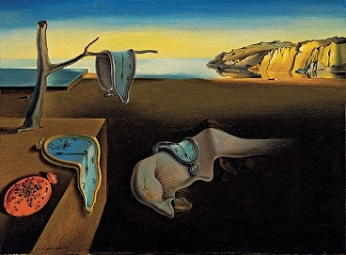 | 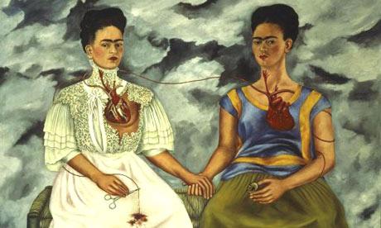
Rene Magritte, Golconde, 1953 | Salvador Dali, Persistence of Memory, 1931 | Frida Kahlo, The Two Fridas, 1939.

Current Interpretations of Surrealism:
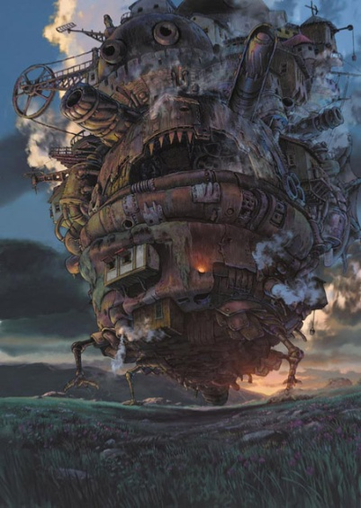 | 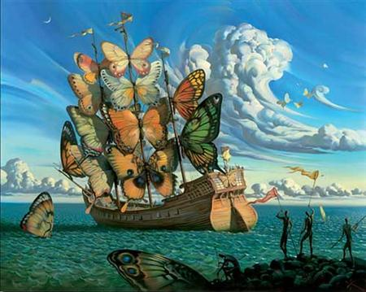 | 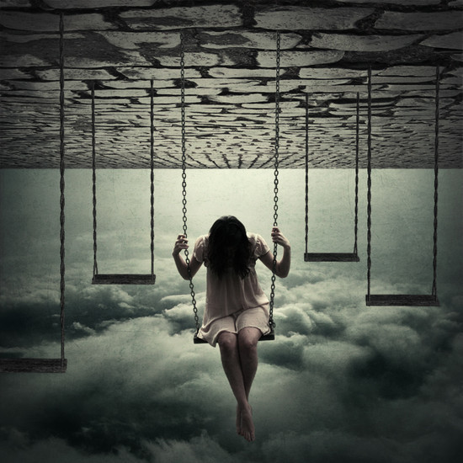
Hayao Miyakzaki, Howl’s Moving Castle, 2005 | Vladmir Kush, Departure of the Winged Ship, 2000s. | http://www.webdesigncore.com/2010/09/13/20-unimaginable-surreal-artworks/ The World is a Playground

How Does Surrealism Work?
- Change of Scale – zoom in or out of an object
- Substitution – replace one object for another
- Placement or Context – take something from its normal place and put it somewhere else
- Combination – take 2 or more things and put them together
- Change of Function – make the object do something that it doesn’t ordinarily do
- Change of Property – change the object’s physical properties ex. make something soft be hard, etc.
AWM2O0 Showalter/Stratford
Surrealist Landscape Painting

Your Challenge:

You will take one of the Surrealist techniques and create a low-relief painting that will be completed using many layers of acrylic paint applied with a dry-brush technique.
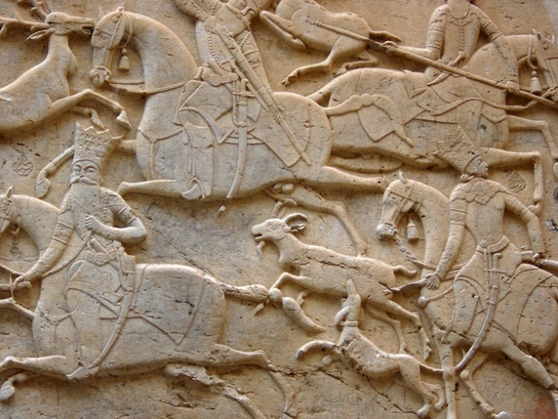

Sketchbook Assignments:
- Surreal Sandwich
- Absurd Collage
- Dry-Brush Experiment(s)

What is Low Relief?

Low relief is created either by carving away material (wood, stone, ivory, jade, etc.) or adding material to the top of an otherwise smooth surface. For example, look at the design on a coin...

http://arthistory.about.com/od/glossary_b/g/bas_relief.htm

A Persian mid-relief (mezzo-rilievo) from the Qajar era, located at Tangeh Savashi in Iran, which might also be described as two stages of low-relief

The Process:
- Choose at least one of the Surrealist techniques (see the other side of this note).
- Create three thumbnail drawings in your sketchbook that use one Surrealist technique in each drawing.
- Choose the design that will be the most effective when assembled in low-relief.
- Carefully cut out your design and glue/apply it to your background.

Make sure that you do not cut directly on the tables!
- When your design is complete and the glue is fully dried, you will begin painting.
- Choose a mid-tone and paint the entire surface of your design. Make sure that you get the paint into all of the little crevices and spaces of your work. Let fully dry.
- Choose a darker tone and dry brush the paint to emphasize the texture. Choose a lighter tone and do the same.
- Finally, choose a metallic colour (gold or silver) and very lightly dry brush a thin, fine coat over the top surface.
- When complete, you have the option of applying a layer of clear gel medium.

Points of Evaluation:
- Thumbnail Sketches [development of ideas]
- Use of Texture [cutting to create real levels]
- Use of Paint [dry brush and layering]
- Degree of Difficulty [simple or complex]
- Attention to Detail [working to your best ability to create the best image possible.]
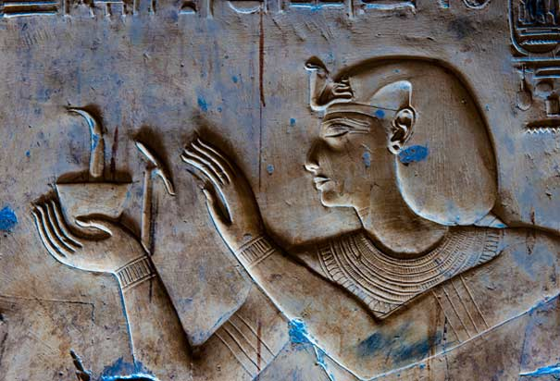 | 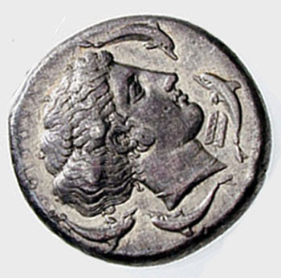 | 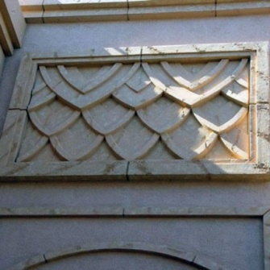 | 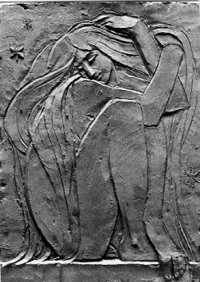
AWM2O0 Name:
Evaluation: Surrealist Landscape Painting
What did you do well on this project? ________________________________________________________________________________________________________________________________________________________________________________________________________________________________________________________________________________________________________________________________________________________

What could you have improved on in this project? How would you do this differently?
_________________________________________________________________________________________________________________________________________________________________________________________________________________________________________________________________________________________________________________________________________________________

Points for Evaluation:
- Three Thumbnail Sketches [development of ideas]
______________________________________________________________________________________
_____________________________________________________________________________________________________________________________________________________________________________________________________________________________________________________________________________________________________________ Student Level ________ Teacher Level _________

- Use of Texture [cutting to create real levels]
__________________________________________________________________________________________________________________________________________________________________________________________________________________________________________________________________________________________________________________________________________________________________________________________________ Student Level ________ Teacher Level _________

- Use of Paint [dry brush and levels]
______________________________________________________________________________________________________________________________________________________________________________________________________________________________________________________________________________________________________________________________________________________________________________________________ Student Level ________ Teacher Level _________

- Degree of Difficulty [basic to complex]
______________________________________________________________________________________________________________________________________________________________________________________________________________________________________________________________________________________________________________________________________________________________________________________________________Student Level ________ Teacher Level _________

- Attention to Detail [working to your best ability to create the best image possible]
_____________________________________________________________________________________________________________________________________________________________________________________________________________________________________________________________________________________________________________________________________________________________________________________________________ Student Level ________ Teacher Level _________

AWM2O0 Name:
Check List: Surrealist Landscape Painting
You will submit the following items to show your completion of this exciting unit!
Assignment Sheet attached in your sketchbook/folder. | Student Level and Explanation
Surrealist Sandwich | Level ___
Absurd Collage | Level ___
Dry Brush Experiment(s) | Level ___
Three Thumbnail Drawings | Level ___
Completed Painting | Level ___
Completed Written Evaluation | Level ___

